Fleming Field, Shotton Colliery, Durham. DH6 2JQ
Tele/Fax: 0191 5261531 Email: ourladyoflourdesdurhamlearning.net Website: http://www.ourladyoflourdes.durham.sch.uk/ Headteacher: Mrs. L. Ashton

12th January 2022

Dear Parents/Carers,

We are delighted to inform you that Our Lady of Lourdes is taking part in the Go Well “Heart Project” this term. The aim of the “Heart Project” is to support children to be active at home with their families and friends. The programme lasts for 12 weeks and each child/family will receive a bag of equipment, a medal, certificate plus information of where they can continue to keep active in the community.

Please find below some further information from the Go Well “Heart Project” team.

Congratulations on your child being selected to be part of the Go Well "Heart Project" - a physical activity "Secret Mission" research team encouraging everyone to be active. Your child has been tasked with testing out a series of challenges in two separate six week booklets using the equipment supplied in the HEART Project backpack. They should work through the pages, test out the challenges and use the stickers to show when they have finished their testing. Every three weeks they should return the booklet to school and they will receive an extra piece of equipment to test out. After six weeks there will be a second booklet with new activities to try. At the end of the project there will be a medal and certificate for all those pupils who have completed the research mission.

Go Well has been awarded funding from Durham County Council Public Health via a COVID recovery fund and the programme is being delivered on behalf of the Active 30 Durham Group to support young people and families, with a focus on physical activity and health and wellbeing during these unprecedented times. We hope your child and wider family enjoy taking part in the project!

You can help us and your child by:
- taking care of the equipment
- finding time to try out the challenges with your child
- encouraging them to complete all of the activities
- assisting them with the feedback and the "It's Your Go" sections
- taking photos and share them with us and Go Well (@gowellwithus on Facebook or Twitter)
- sending us and/or Go Well photos of the "It's your Go" sections from week 3 - they may be included in the next booklet! (HEART@go-well.org)
- reminding them to bring the booklet back into school every 3 weeks

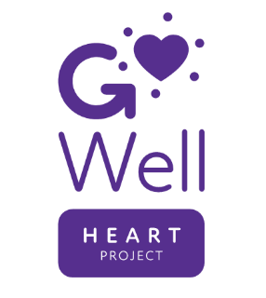
Go Well and our school are extremely grateful to all of the funders for allowing us to take part in this project. All of the equipment is for your child to keep following the "Secret Mission". We hope they and your family continue to use it to keep active, keep moving and keep healthy.

Yours sincerely,
Miss Croxford

