Dear Parents / Carers,
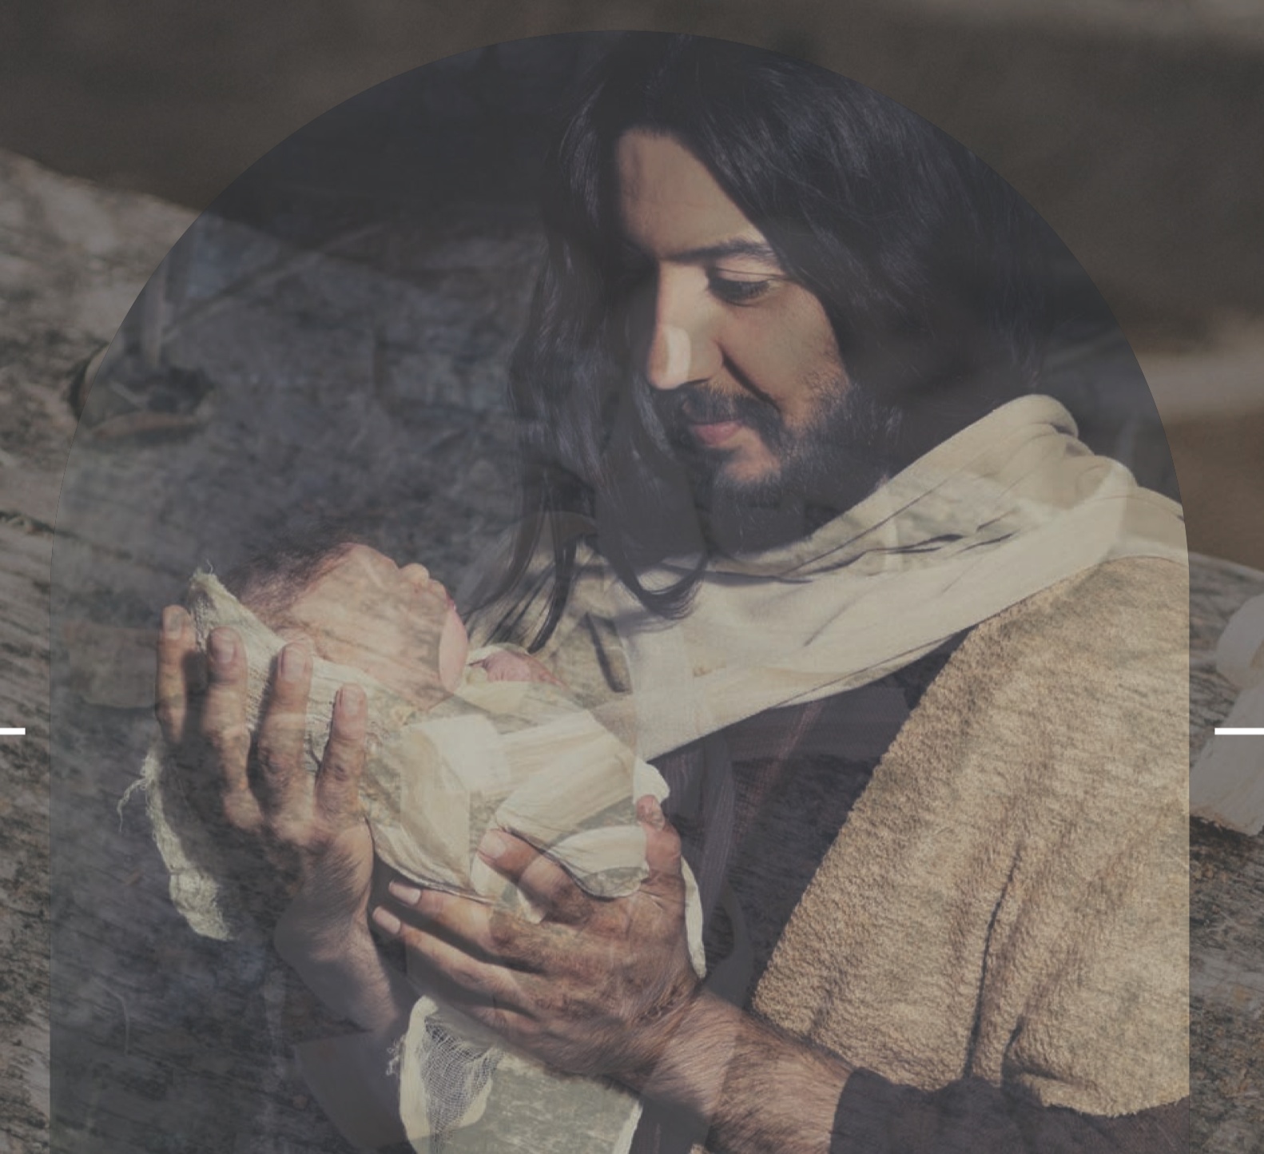

Summer Term has arrived and we are pleased to be back in our own classroom again, where it is lovely and cosy with our new heating system. The children have been excellent ambassadors for our school while working from St Bede’s over the last term, showing great resilience and settling back into school life brilliantly following the recent lockdown.
PE will continue to take place on a Monday and Friday, so please send your children into school dressed in jogging bottoms/leggings, with trainers and their school PE T-shirt and school jumper.

Always a busy term, we have lots of new and exciting topics to learn about, including Violent Volcanoes and our local coastline in Geography; animals and their habitats in science and the Anglo Saxons in history. For more information, take a look at our Summer Term planning.

In RE, we will be learning about New Life, Building Bridges and God’s People. Alongside this, the Pope has requested that this year be recognised as the year of St Joseph. Each month in school, we will look at Joseph’s many qualities and apply this to our own learning.

We look forward to working with your child this term. Hopefully, the weather will continue to improve and we will be able to make the most of our time outside.

As always, should you have any questions, please do not hesitate to contact me on k.smith201@ourladyoflourdes.durham.sch.uk or call the office and I will be in touch.

Best Regards,

Mrs Smith

