**Staying safe as the weather changes**

As the weather often fluctuates, please help us keep your child safe by ensuring that they are wearing a cap and have sun cream on to protect them when the weather is warm. At the same time, could you please make sure your child has a jumper or cardigan (labelled with their name) in case it turns a little colder.

Please also ensure that your child has a water bottle so that they can stay hydrated throughout the day.

**Homework**

Reading books will be sent home on a Friday and must be returned on a Monday, with your child’s reading record signed, Our children have access to Times Table Rockstars and Num Bots, which can be used at home. Please encourage your child to have some fun with addition, subtraction and their times tables.

[Times Tables Rock Stars (ttrockstars.com)](https://ttrockstars.com/)

[NumBots | Motivational maths practice for schools and families.](https://numbots.com/)

PE/ Outdoor Learning

P.E. takes place on a Wednesday and Friday. We ask that the children come to school in their PE/ outdoor learning kit which includes their school jumper. We are very lucky this year to have Scout-Ed on a Wednesday, taking our learning outside. During these Wednesday sessions, we be learning to become more resilient, independent and critical thinkers. Sometimes our learning will be messy, so we ask that your children come to school dressed in suitable warm clothing that you won’t mind getting dirty e.g an old tracksuit and wellies. It would be useful if your child could also bring a spare pair of shoes to change into after these sessions (trainers or school shoes). Please can you make sure that all your child’s belongings are clearly labelled.

If you have any queries, please feel free to email me on [y.harker300@durhamlearning.net](mailto:y.harker300@durhamlearning.net) . Many thanks.

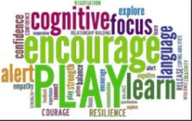

Our Lady of Lourdes R.C. Primary School

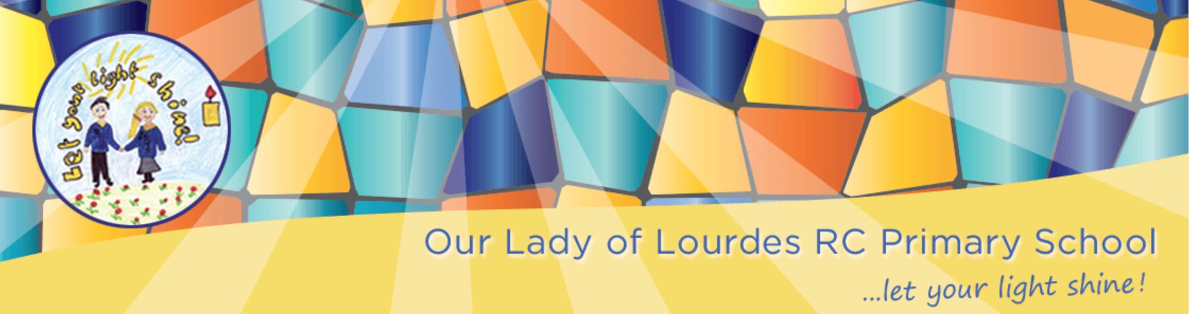

Year 2 Newsletter

Summer Term 2021

Welcome back to an exciting summer term. This year has been a very unusual year for everyone and we would just like to say thank you for how supportive and fabulous you and your children have been over the past year.

As we finish our school year we will be placing great emphasis on the children’s health and well-being. We will be helping your child reach their full potential this summer term, with your help, and through fun engaging lessons.

**Science**: We will learn all about plants and growing our own salad! We will observe and describe how seeds and bulbs grow into mature plants. We will find out and describe the needs that plants have. During the second half of the term, we will learn about and describe the basic needs of animals and humans, describing the importance of exercise and the correct type of food on maintaining a healthy lifestyle.

**History**: Our topic is learning all about summer holidays in the past. As part of our learning, we will explore and use a range of vocabulary relating to the past. We will learn about timelines and how people used to holiday in the 1950s.

**DT**: During our DT sessions we will be applying our scientific knowledge to design and create our very own healthy meal to share.

**Art**: As artists we will be looking at pop art and focussing on the artist Andy Warhol, researching and evaluating his work. We will explore his use of thick lines and bright colours to create pieces of bold artwork.

**Computing**: During our computing sessions we will use our coding skills, to create our very own program and quiz.

**Geography**: We will be exploring holidays. We will spend some time comparing and contrasting the UK and Kenya, focussing on the differences and similarities these places have.

**Music**: We will be focusing on various skills, in particular ‘listening attentively to a range of music’ in our lessons. We will focus on songs around the theme of friendship.

**Maths**: During the summer term we will continue to work on our key skills within our maths lessons. We will be consolidate our addition and subtractions skills using one and two-digit numbers. We will be working on rapid recall of number bonds to 100 and their related facts. We will then move onto geometry identifying 2d and 3d shapes and lines of symmetry. We will also be learning about fractions of shapes and amounts. During year 2 we have been developing our understanding and recall of the 2,5 and 10 times table multiplication and division facts. During the second half term we will compare length, height, mass, capacity, temperature, and time using a variety of practical methods to help embed our learning. Using all of these we will grow and develop our resilience and problem-solving skills whilst completing different challenges.

**English**: We will continue to build up our phonic skills with **daily** phonic sessions during the summer term with a focus on adding suffixes and prefixes to change word meanings. Perhaps the children could show you what they have been learning at home. You could also help consolidate learning by playing on some interactive games such as: <https://www.phonicsplay.co.uk/> We aim to continue to foster a love of reading in Year Two, where children want to learn to read for information as well as enjoyment and pleasure. Your children love to read and share stories at the end of the day, and I would encourage you to keep reading with them at home. This term our focus will be on a selection of poems, fiction and non-fiction books related to the seaside, earth day and animals. When writing, we will be continually focussing on key skills whilst composing and writing sentences.

!

**Religious Education**: In R.E. we will be learning about:

**Spread the word.** *Suggestions for home activities:*  * Each of us, by the way we live our lives, the way we treat others, and by our words and actions, show if we have an attitude of service.

Talk about the return of Jesus and how the Holy Spirit helps us live our lives through God. **Rules** *Suggestions for home activities:*

* Christians believe that, in Jesus Christ, the world has been reconciled to God.

Talk about how through and in Christ, every human being is offered the power to reach out in forgiveness and peace, to receive and to offer reconciliation.

**\***