RE
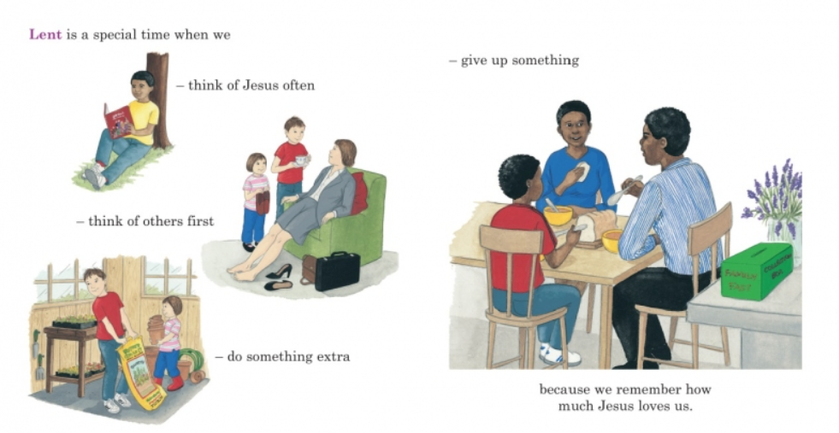

At this time, we prepare for Easter and begin to think about what Lent can offer and what we can do to prepare for this special time. Think about these questions and complete the task.

- What opportunities does Lent offer?
- Which opportunity for doing good will our class choose during Lent?
- How will we do this?
- How might Lent help Christians to be better people?
- What good things can we do to help our wider community during Lent?

Design a poster describing some of the actions that Christians might do during Lent.

