Religious Education

Year: 4 Teacher: Mrs Smith Week Beginning: 22.02.2021
Statement to live by
I try to use words that make the world a better place.
Throughout this week, think about the words you use when talking to others and count up how many times you say a kind word to someone.

Being thoughtful for life in giving, for people and gifts, is a vital part of our relationship with one another. When we experience praise and appreciation, we feel happy and loved. Read the story about Ethan below and discuss the following questions.

Questions to discuss:
- What do you think of Ethan behaviour at breakfast?
- What do you think made Ethan realise that the way he had behaved at breakfast was silly?
- How did Ethan feel?
- How did Ethan show he wanted to give and not just receive?
- What made Ethan happy?
- What do you think about giving and receiving?
- What has been your experience of giving and receiving?

Your task is to create a storyboard (see example on page 3) showing times throughout a normal day when you give and receive (at home, at school and other groups).

What a day!

The day did not start well today. First thing this morning, mum asked me to help her with the breakfast – just to put the cereal on the table. I said ‘No’.
She was cross.
Then my little brother, Charlie, knocked his juice over. I was not going to pick it up. He is always doing that. He began to cry. Dad was annoyed and told me to pick it up.
‘No’, I replied again, ‘why should I? He’ll only knock it over again. Mum, have you got my stuff ready for swimming today and I want a chocolate biscuit for my packed lunch not a mouldy old cereal bar.’
Mum stopped what she was doing. She didn’t look very happy and asked me what was the matter and why was I so cross. She made me sit down and think about what I had said.
Dad explained that everyone has bad days but life is full of giving and receiving. He asked me to think about what I receive at home – care, love, a packed lunch ready for school, my swimming kit put in my bag and that sometimes it is my turn to give, by helping and being kind.
I shrugged my shoulders and said nothing, I still felt cross. ‘Come on Ethan,’ called Dad, ‘you don’t want to be late for school when it is swimming today.’
Dad and I walked to school. When I got there, I didn’t say goodbye but rushed into the playground.
During prayers in the morning, I thought about what had happened earlier. I felt miserable. I knew I had been selfish. When we got on the coach to go swimming, I saved a seat by the window for my friend Connor, because I knew he liked that seat.
‘Thanks,’ he said with surprise. When we got into pairs, I let Connor choose which float we were going to use.
On the way back to school, Connor said how much he had enjoyed the lesson today and that I was a good friend. I felt really good.
When I got home I gave mum and Dad a hug and told them I was sorry, and said, ‘I think it is more fun when you give.’ We all had a happy evening.

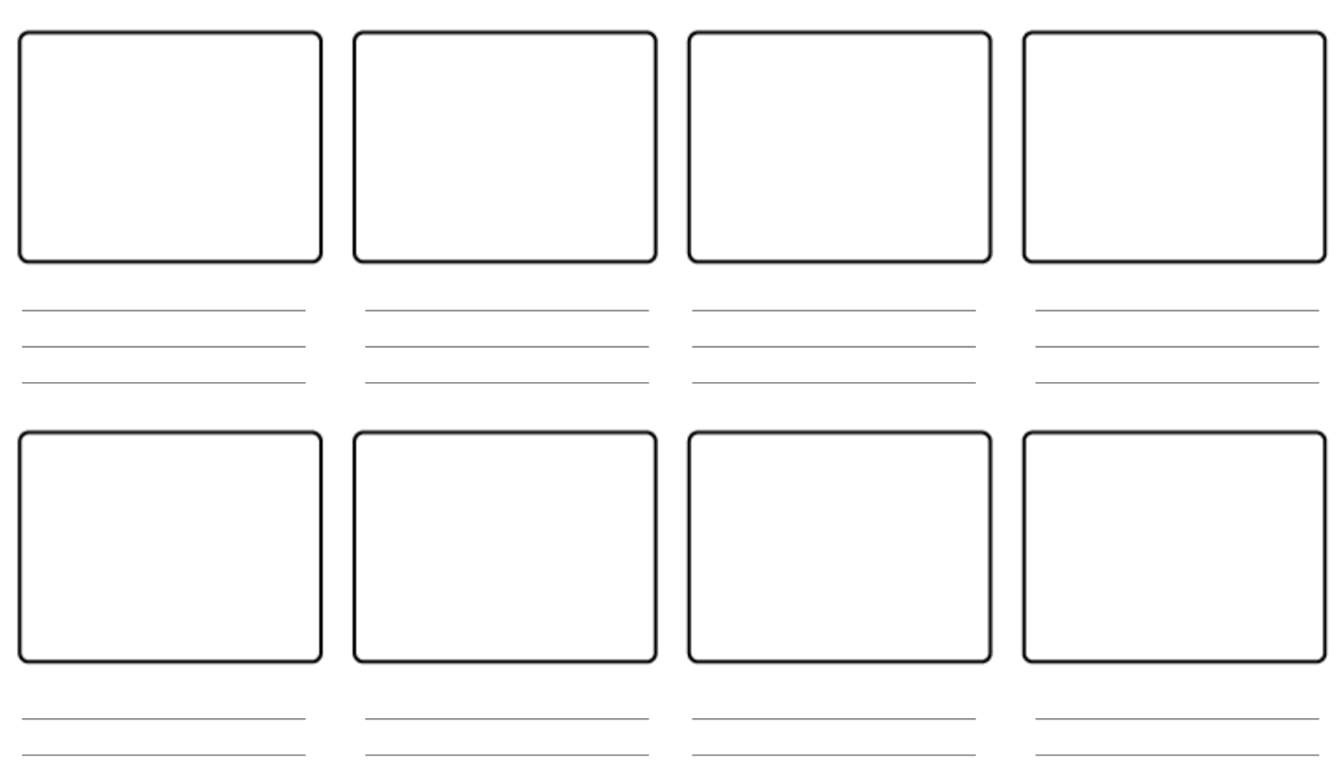
Draw a picture in each square and write underneath how this shows giving or receiving. You do not need to use all the boxes.

