Year 2 Phonics Planning—WB: 8.2.21
Weekly Focus Adding the suffix -er, -ing and -ed

 | Objective | Activity
Mon | Using the suffix ‘er’ ‘ing’ and ‘ed’ | First have a go at spelling and reading this week’s common words:  Gave, may, still, found, say, soon, night  Over the last few weeks, we have looked at these different suffixes ‘er’ ‘ing’ and ‘ed’.  Let’s see if you remember how to add these suffixes.  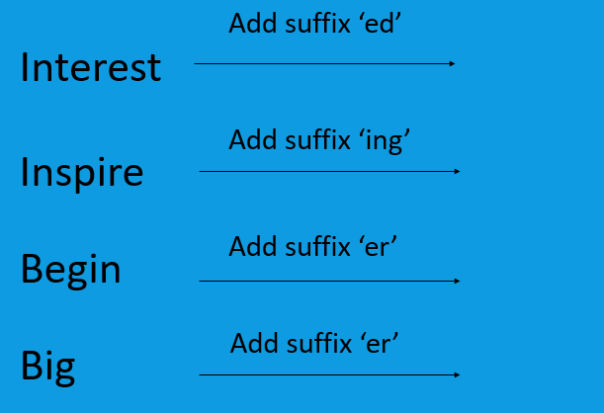  Your spellings this week are:  pleased, cried, disappointed, shocking, challenging, amazing, jogger, caller, riper, spicier  Practice reading them then have a go at using them in a sentence.
Tue | Using the suffix ‘er’ ‘ing’ and ‘ed’ | First have a go at spelling and reading this week’s polysyllabic (complex) words:  Nightmare, nightdress, founder  Discuss memory strategies to help you remember how to spell these words.  Can you remember the rules for adding the different suffixes?  Read the piece of text on Tuesday’s task page below or ask an adult to help you. You need to spot the mistakes I have made when adding the suffixes ‘er’ ‘ing’ and ‘ed’. Write the correct spelling in your books. See if you can spot all the mistakes!
Wed | Using the suffix ‘er’ ‘ing’ and ‘ed’ | Can you write some sentences using words that end in the suffix ‘ed’ ‘er’ and ‘ing’. You can use your spelling words if you like or any words you may think of e.g. collecting, jumped, rougher, copier. Can you manage to write 4? Or more?  Check your spellings of the words you added your suffixes to!
Thu | Using the suffix ‘er’ ‘ing’ and ‘ed’ | Can you write a paragraph using the different suffixes ‘er’ ‘ed’ and ‘ing’. You could think of a setting e.g. the beach or the forest and write a piece of work about that. You can use my example from Tuesday’s task page to help you if you would like. Check your spellings of the words you added the suffixes to!
Fri | Using the suffix ‘er’ ‘ing’ and ‘ed’ | Spelling Test  See how many of this week’s spellings you can get right!  pleased, cried, disappointed, shocking, challenging, amazing, jogger, caller, riper, spicier

Tuesday

Spot the mistakes that I have made when adding the suffixes ‘er’ ‘ing’ and ‘ed’.

