
Year 4 English Planning—WB 25th January 2021
Weekly Focus: Explanation Texts
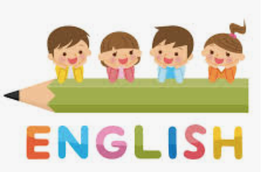
 | Activity
Monday | Reading Comprehension Activity  Read the text about the Water Cycle and answer the questions as clearly as you can.
Tuesday | Spelling - Words with the sh sound spelt ch  Work through the segment cards activity from  https://spellingframe.co.uk/spelling-rule/19/16-Words-with-the-sound-spelt-ch-(mostly-French-in-origin)  Complete Spelling Tuesday.pdf
Wednesday | Watch the video about paragraphs in non-fiction from Microsoft Teams  Answer the questions from Wednesday grammar, being as clear as possible in your reasoning.
Thursday | Read about the features of an explanation text  Complete the activity Text Marking Explanation Text.pdf
Friday | Spelling Quiz -Recap your spelling and test yourself  https://spellingframe.co.uk/spelling-rule/19/16-Words-with-the-sound-spelt-ch-(mostly-French-in-origin)  Complete the activity identify features of an explanation text.pdf

Reading – Spend a minimum of 15 minutes each day on Reading Plus.

