Our statement to live by this week is:
I listen to what you say. I show that I am listening to you.
This week try hard at home to listen to your adults.
Religious Education
Year: Two Teacher: Miss Harker Week Beginning: 1st February 2021
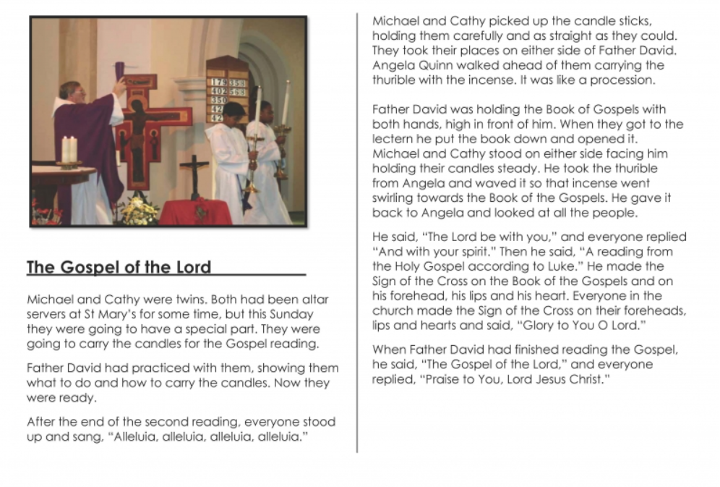
Watch the video of the Gospel shared in resources or read the text below and think about the questions below.

- What did you notice about the way the Book of the Gospels is treated?
- What did Michael and Cathy do?
- How did everyone greet the Gospel?
- Why do you think people make the sign of the Cross three times on themselves before they listen to the Gospel?
- What did Father David say before he read the Gospel?
- What did he say at the end?
Can you remember the responses to the Gospel reading?
Can you practise responding to the Gospel at home?

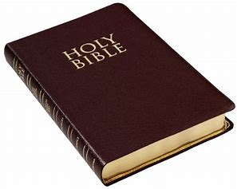
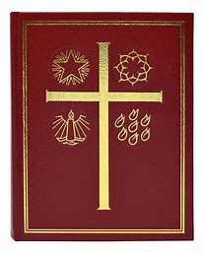
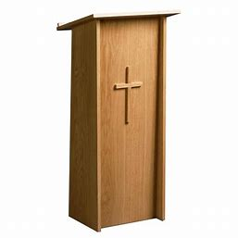
Can you match the word to the picture (if you can’t print draw the picture and label it).

Bible

Lectern

Lectionary

Thurible

Can you say what these religious items are used for?

