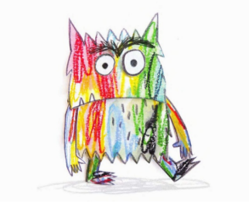**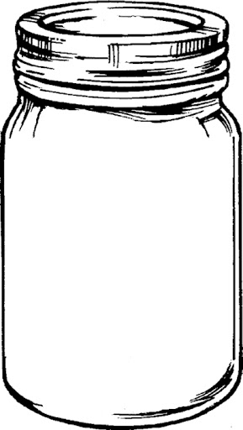What’s in your jars?**

**calm**

**love**

**sadness**

**fear**

**anger**

**happiness**