Wednesday 27th January 2021
LO: Using Paragraphs
1. Choose the best sub-heading for the paragraph below.
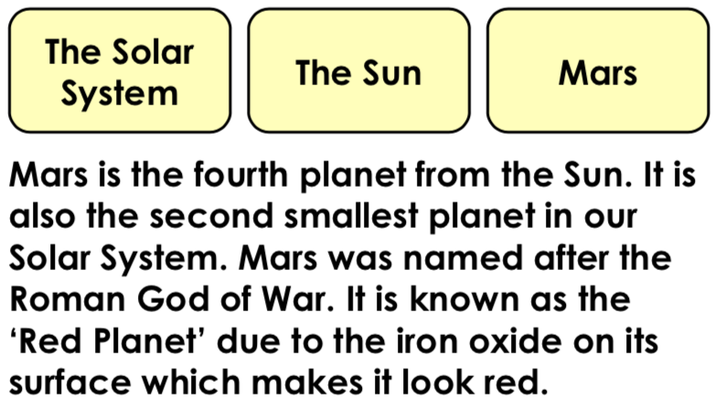
2. Choose the best word or phrase to start the paragraph below.
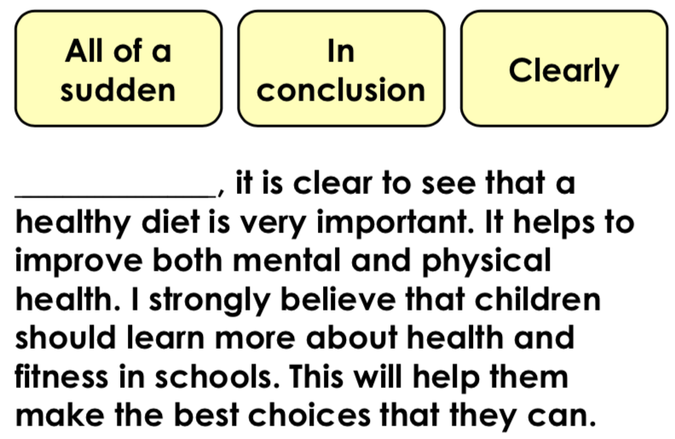
3. Write a suitable sub-heading for the paragraph below.
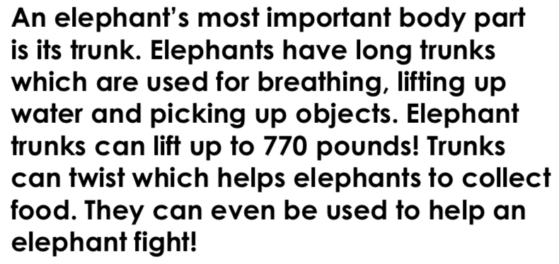
4. How would you order the sub- headings below?
Text 1 Text 2
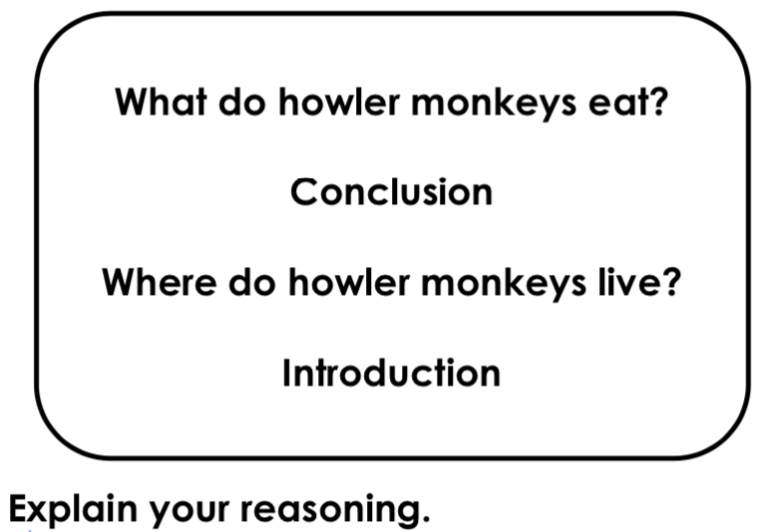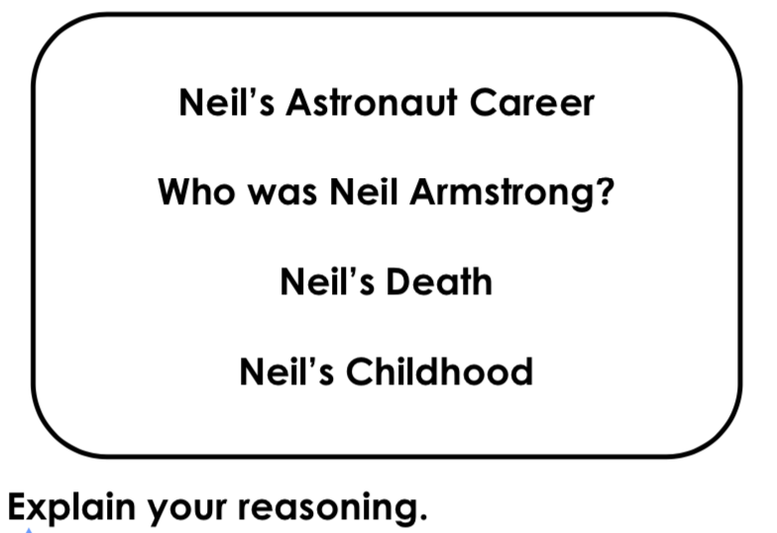

5. Read the paragraph below and explain what mistake has been made.
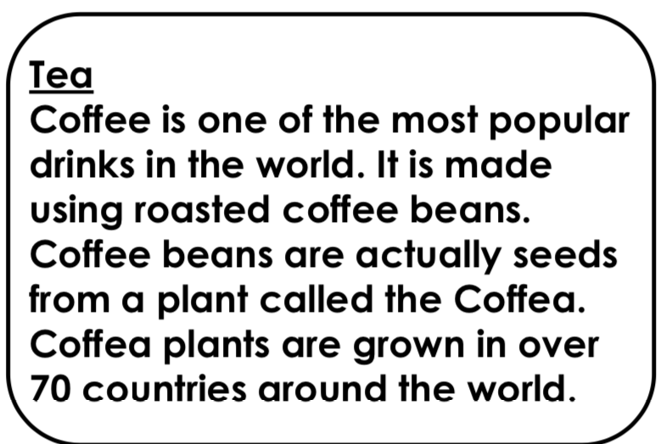
6. Read the paragraph below.
Decide where the paragraph should be split and rewrite it.
Tigers are the most recognised large cat species. This is due to their unique coat pattern of dark, vertical stripes on reddish-orange fur. They once roamed widely across Europe and Asia. In the last 100 years, however, they have lost an estimated 93% of their range. The primary reason for this is due to the destruction of their habitat by humans.

