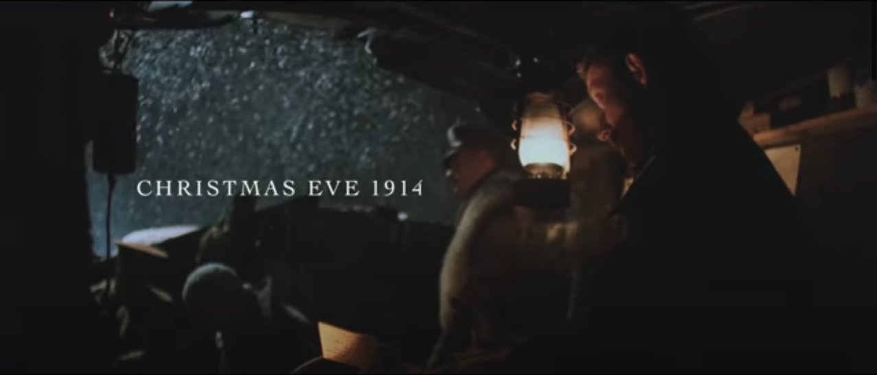
It is Christmas Eve in 1914, The Great War began 5 months ago. The British soldiers are sat in the trenches, thinking of home.

White flakes of snow are falling all around, the man’s fingers are numb and their breath can be seen rising from the trenches.

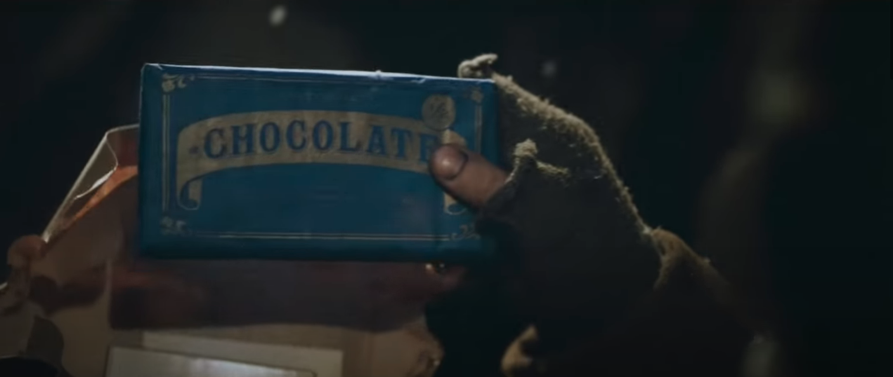
Letters and gifts have all arrived from home. One soldier received a picture of the girl he loves as well as a bar of chocolate.

The trench is dark, damp and dreary.

