L.O To research the rainforest habitat.
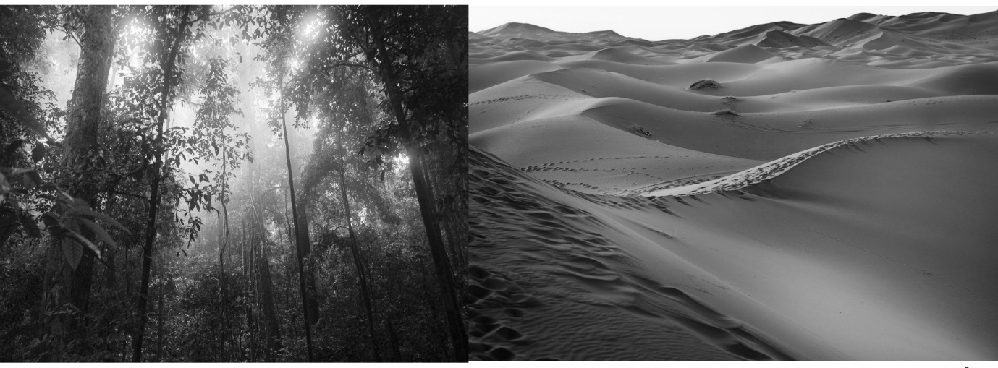
What are the differences between these habitats?
What animal matches the description?

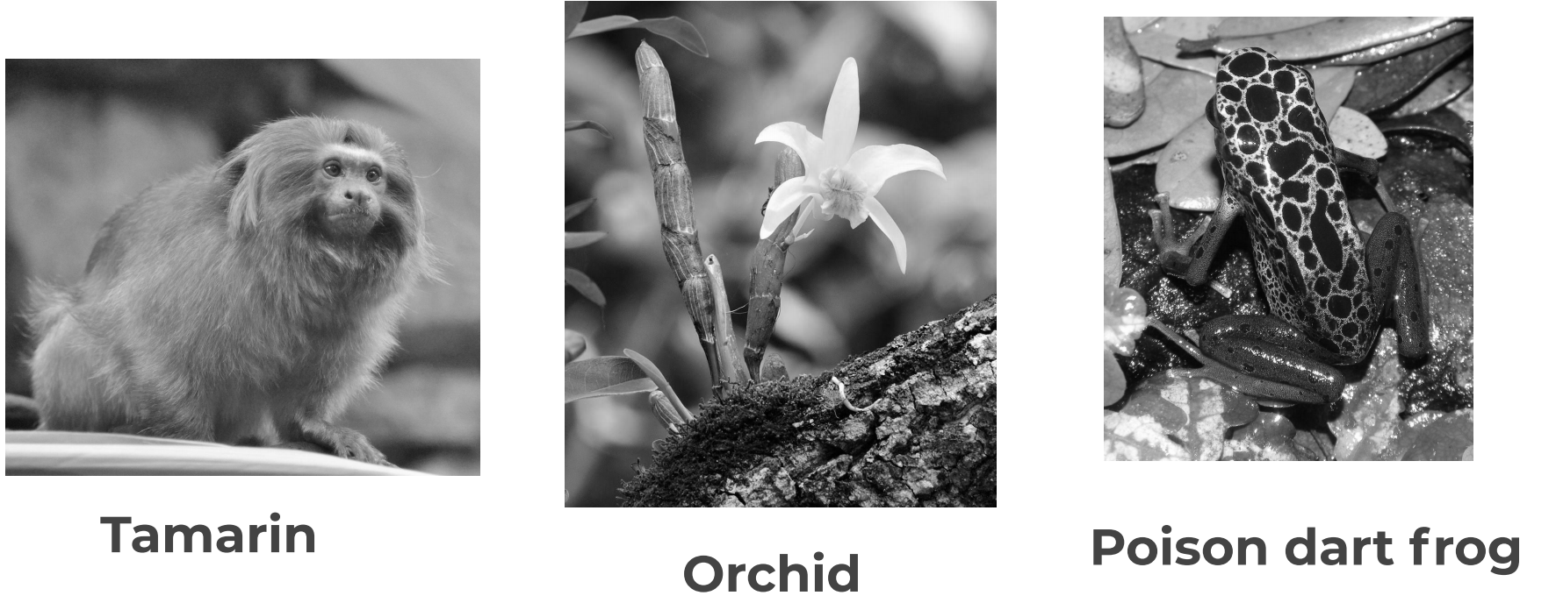
An omnivore that eats fruit, flowers, amphibians and insects.
Grow on trees.
Brightly coloured to attract insects.
Brightly coloured to warn off predators.
Occupies a territory of 100 acres.

