Problem Solving Week Beginning 4th January

1.
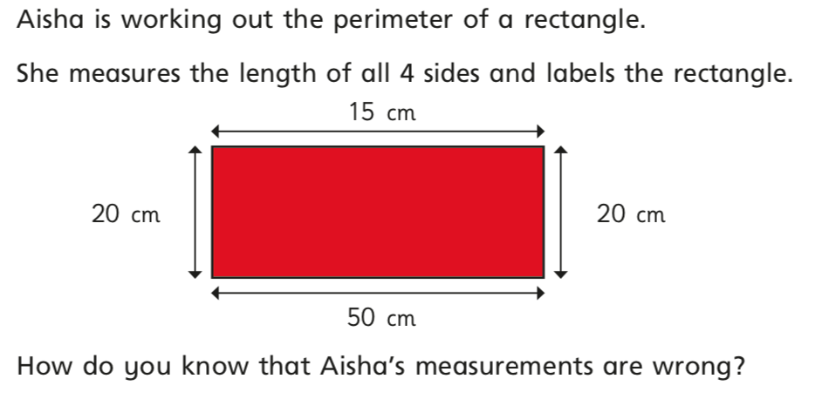
2.
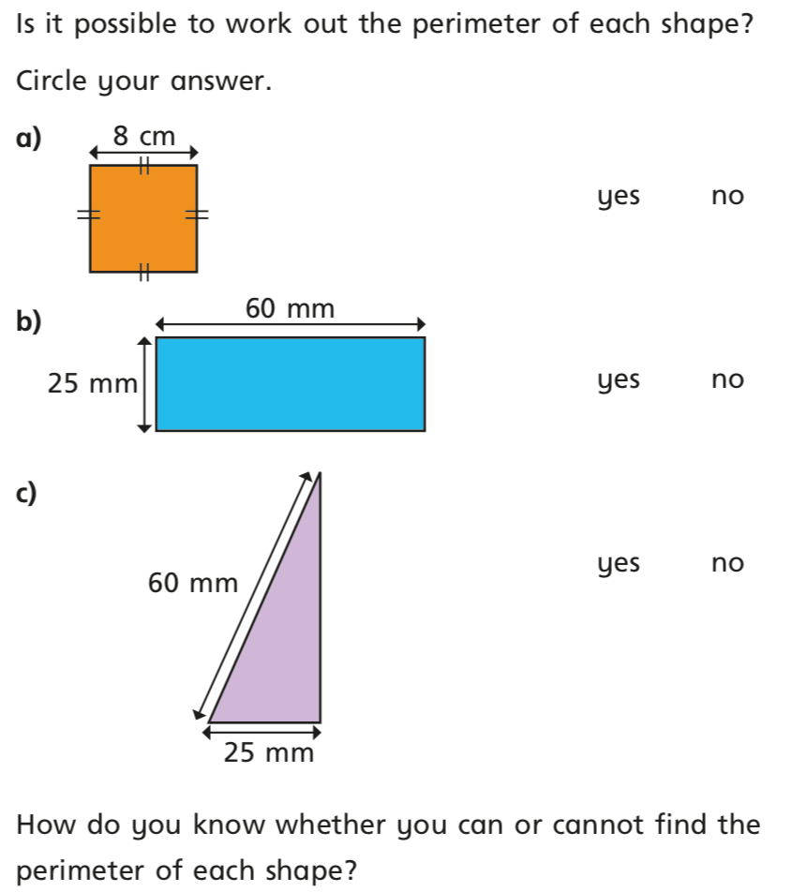

3. 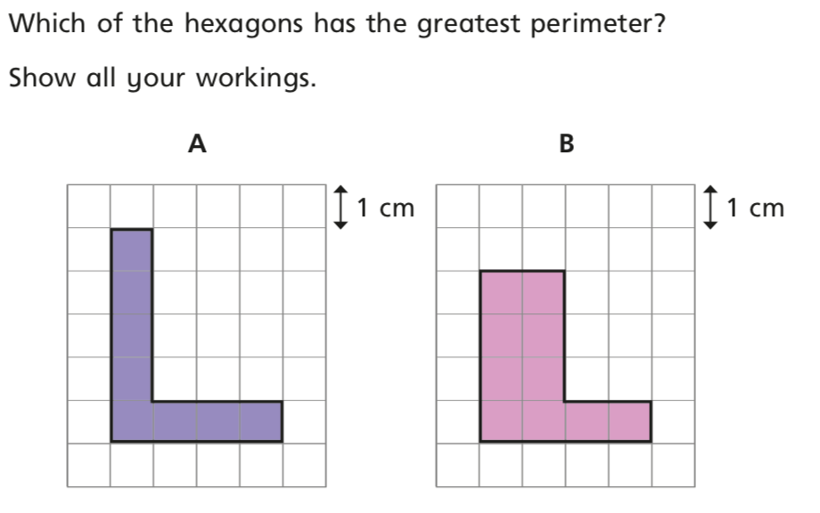

4.
.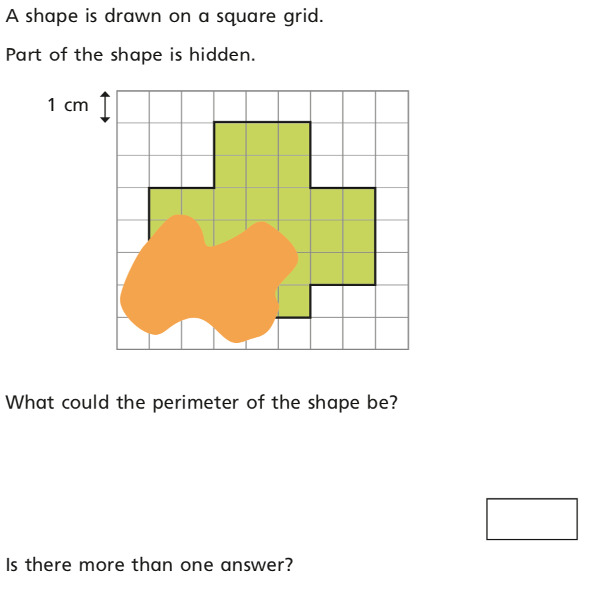

5. 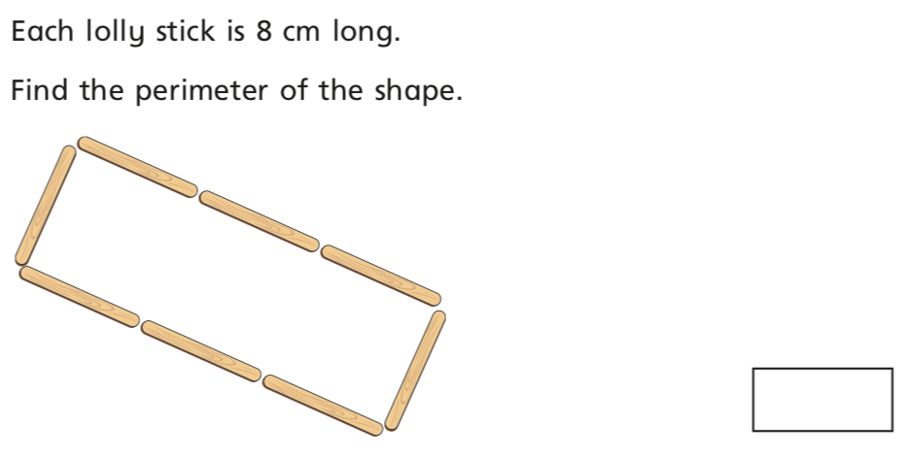

6. Henry has drawn a rectangle with a perimeter of 44cm, but a paint splat has covered the measurement of each side.
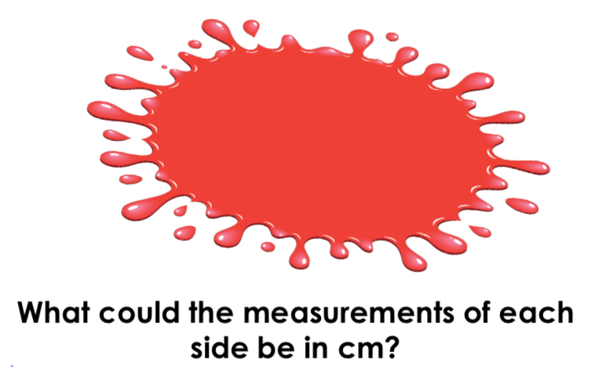

7. This wall is made up of stones. Each stone has a length of 16cm and a total perimeter of 42cm.

