Reasoning and Problem Solving WB 11.01.2021 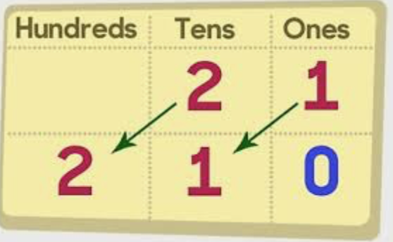

1. The numbers below are the journey times in minutes to three destinations. Use the clues to match the child to their journey time. 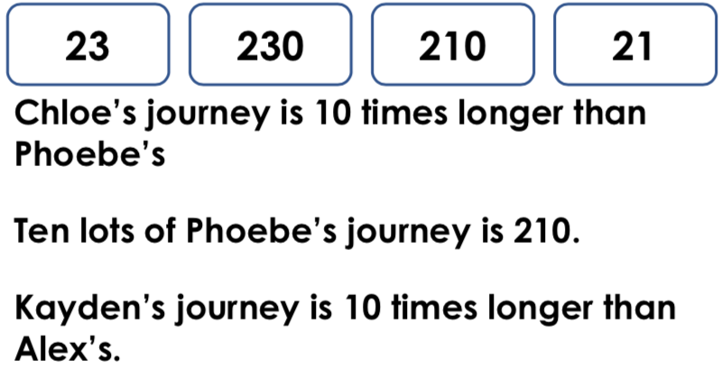 | 2. Tom buys a pack of football cards. There are 10 cards in a pack.  He needs 245 cards to fill his football album.  His mum buys him 23 more packs.  Does Tom have enough cards to fill his album?  Explain how you know.
3. 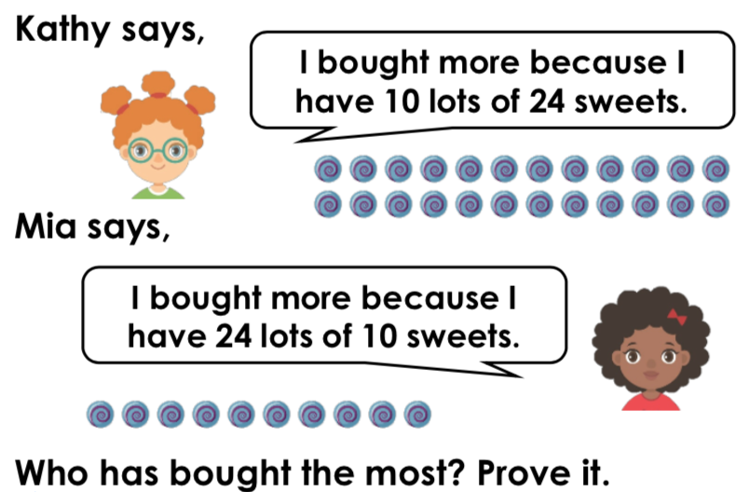 | 4. Use the digit cards to complete the calculations. You can use each card more than once.  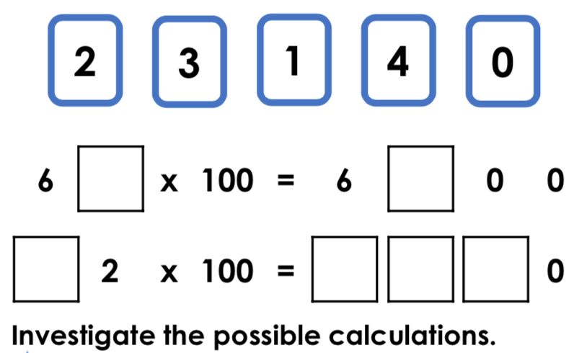
5. Emily is going to order some pencils in boxes of 100. There are 1,850 pupils in the whole school.  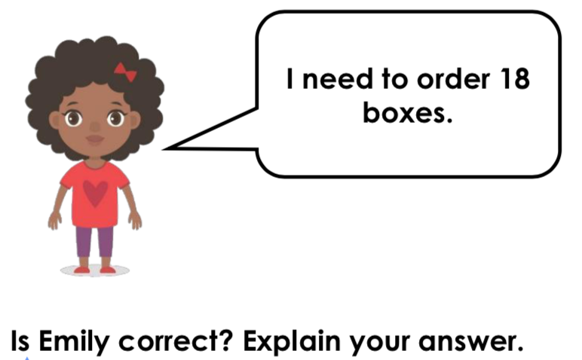 | 6. Ruby has completed the statement below.  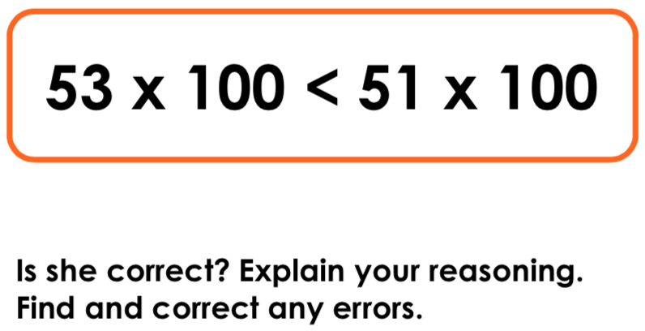

7. Evie and Leo are reading books in the library. They take 10 minutes to read each chapter.  Altogether they read for 340 minutes. | Trent thinks he has divided 960 by 10 to find the answer below.  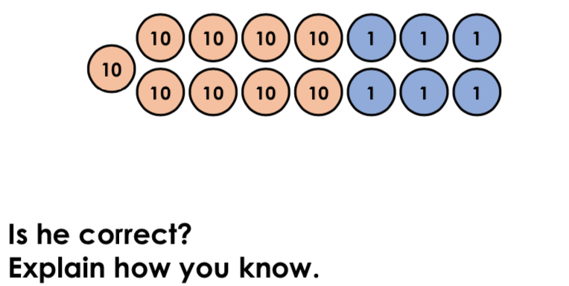

Answers

- Phoebe = 21; Kayden = 230; Alex = 23; Chloe = 210.
- No, because 24 x 10 = 240 and he needs 245.
- They both have the same because 10 x 24 = 24 x 10.
- Various answers, for example: 63 x 100 = 6,300; 42 x 100 = 4,200
- No, Emily is incorrect because she needs 19 boxes. 19 x 100 = 1,900 which will be enough for all the pupils at her school.
- Ruby has not completed the statement correctly because 5,300 is not less than 5,100. The wrong symbol has been used. The correct statement is: 53 x 100 > 51 x 100.
- Various answers, for example: They read 34 chapters altogether; 15 and 19, 20 and 14, 9 and 25.
- Trent is correct because 960 ÷ 10 = 96.

