Religious Education

Year: 4 Teacher: Mrs Smith Week Beginning: 04.01.2021
We are starting our new topic of Community. In order to do this, we need to think about what community means?
A group of people living in the same place or having a particular characteristic in common.
Each one of us belongs to a number of different communities, e.g. school, parish, family, town where we live.
Read the Castleford Council Estate story below and think about the following questions
Questions to discuss:
- Why was the Castleford estate a happy place to live?​
- ​Why do you think Sister Christine helped the Castleford community?​
- ​What do you think is meant by the word community?​
- ​What are the advantages of being part of a community?​
- ​What are the demands of being part of a community?​
- ​What do you think could cause the breakdown of a community?​
- ​What helps to build up community?​

Think about all the communities you belong to and other people in it. Complete as many people as you can think of who work in your community, stating what they do, what they are committed to doing and why they do it.
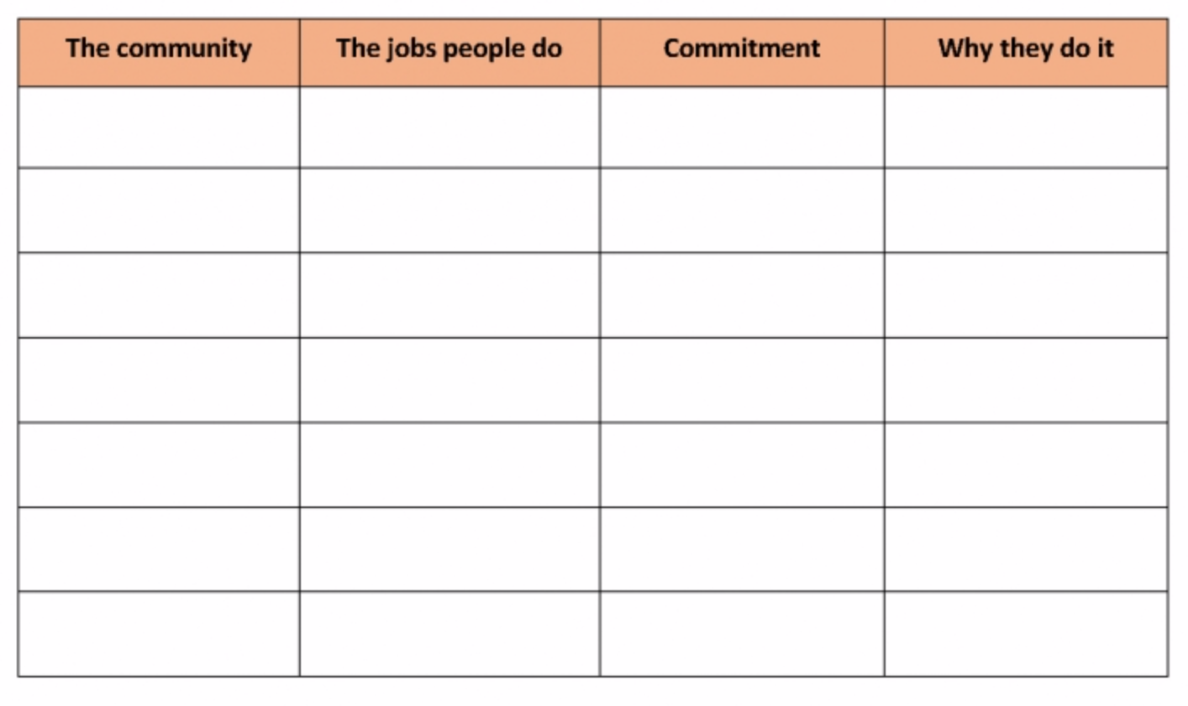

The Castleford estate where Jack and Holly lived had a good community. Sister Christine who lived there was always thinking of good ideas to bring people together and help them take responsibility.
There were after school clubs to help children with homework, a rota for visiting the housebound people, a football club, a pre-school group where parents and carers could meet and talk. Sometimes, there were outings. Sister Christine organised a residents’ committee, which had responsibility for running the various activities and everyone who wanted to, had a part to play. The estate was a happy place to live.
One day a new family came to live on the estate. They had a little boy, called Alfie who was deaf. Alfie went to a different school from the other children on the estate, so he did not know anyone. Jack saw him coming home from school and told Holly about him. They had not seen him at any of the activities. So, they decided to go and visit him…

