Religious Education
Year: 6 Teacher: Mr. Merrington Week Beginning: 4th January 2021

Our R.E. focus this week will be on books and their purpose.

I want you to think about your favourite books, now pick one of them that means a lot to you, pick one special book. This doesn’t have to be your favourite story, it doesn’t have to be a long story, it just has to be special to you. Here is my special book as an example for you:

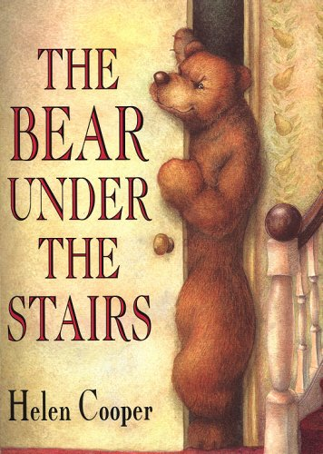
The Bear Under the Stairs
This book will forever live in my memory and on my bookshelf; it is a very special book to me. The reason this book is so special is because it reminds me of being very young and going to the local library every week with my Mam. We would go on the same day every week and every week I would pick this book up and ask my Mam to take this one home. Every week my Mam would try to persuade me to pick something different, so I did, but I kept hold of The Bear Under the Stairs too. Every week when we got home from the library we would have a different book but we always had The Bear Under the Stairs too. Even though my Mam must have known every word in the book by now she would still read it to me, this is a special memory I have and this is what makes this book special to me.

Your task now is to write a paragraph like I have to explain to me why your book is special to you. See if you can draw a little picture to go with your book, you could maybe copy the front cover or create your own front cover for your special book.

