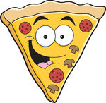
Research

1. Where does pizza come from?

2. What is pizza made from?

3. What shapes and sizes are pizzas?

4. What sort of toppings can pizza have?

5. What different packaging can pizzas have?

Your favourite pizza

When do you eat pizza?
Who do you eat pizza with?
What is your favourite pizza topping?
Draw and label your favourite pizza.

