Year 2 Phonics Planning—WB: 25.1.21
Weekly Focus Adding the suffix -er

 | Objective | Activity
Mon | Using the suffix ‘er’ | First have a go at spelling and reading this weeks common words:  Never, next, first, lots, need, fish  This week we are going to be using the suffix -er. But first let’s have a recap of last weeks suffix -ing. Can you add ‘ing’ to these verbs?  Your spellings this week are:  teacher, carrier, sticker, runner, driver, rubber, digger, baker, builder, worrier  Practice reading them then have a go at using them in a sentence.
Tue | Using the suffix ‘er’ | When we add the suffix ‘er’ it changes the verb into a noun (usually a person).  Let’s explore the rules when adding the suffix ‘er’ to verbs:  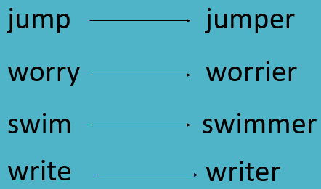  Can you see what is happening to the verbs to make them nouns? What rules are there for adding ‘er’? For example, when adding ‘er’ to a short vowel with two consonants you add ‘er’.  Can you write down all the rules?  Are there any memory strategies you could use to remember these rules?  Can you think of any irregular words that don’t fit these rules? For example, listener as you don’t double the consonant (n).
Wed | Using the suffix ‘er’ | Have a go at adding ‘er’ to the words on Wednesday’s task page below. Remember the rules for adding ‘er’ you looked at yesterday. Can you think of anymore verbs that you can add ‘er’ to, to make a noun?  Can you say some sentences with these words in?
Thu | Using the suffix ‘er’ | Think of a verb, act it out and see if your adult can guess. For example, you could pretend to be mixing ingredients in a bowl for bake. Then tell your adult the answer by using it in a sentence e.g. I am a baker because I can make cakes.  Can you write 4 sentences of your own using the verbs and adding ‘er’, you can use your spelling words if you want or the ones you have just acted out.
Fri | Using the suffix ‘er’ | Spelling Test  See how many of this week’s spellings you can g  et right!  teacher, carrier, sticker, runner, driver, rubber, digger, baker, builder, worrier

Wednesday

Have a go at adding ‘er’ to these words. Remember the different rules!

