Feelings are often described as similes or metaphors and discuss their meaning, for example:

- Colours: ‘she saw red’, ‘feeling blue’, ‘in a black mood’, ‘tickled pink’ or ‘green with envy’
- Temperature: ‘fiery temper’, ‘boiling over with rage’ or ‘cool as a cucumber’
- Images: ‘over the moon’, ‘shaking like a leaf’ or ‘walking on sunshine’

Choose one of the words from the feelings list below, or use one of your own. Write it on your page and using a body outline (example below) as a basic template on which to draw and write to respond to the following questions:

- If you could explain where in the body someone would experience that feeling, where would it be?
- If the feeling had a colour, what colour would it be?
- If it had a shape what shape would it be?
- If it had a texture, what texture would it be?
- If the feeling were an image or a picture, what would this be?
- If the feeling had a sound, what sound would this be?

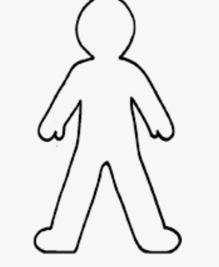

Emotions words
