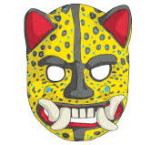
Three things I like about this mask:

Three things I dislike about this mask:

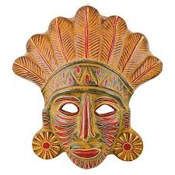
Three things I like about this mask:

Three things I dislike about this mask:

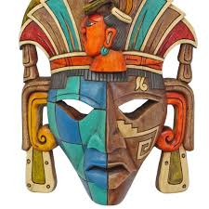
Three things I like about this mask:

Three things I dislike about this mask:

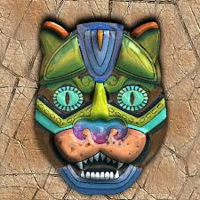
Three things I like about this mask:

Three things I dislike about this mask:

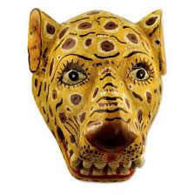
Three things I like about this mask:

Three things I dislike about this mask:

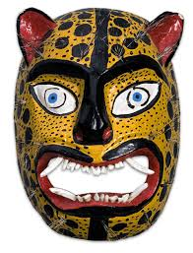
Three things I like about this mask:

Three things I dislike about this mask:

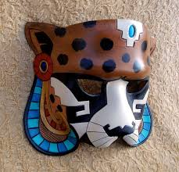
Three things I like about this mask:

Three things I dislike about this mask:

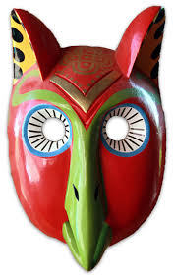
Three things I like about this mask:

Three things I dislike about this mask:

