Thursday Maths

L.O: Cube numbers

1. 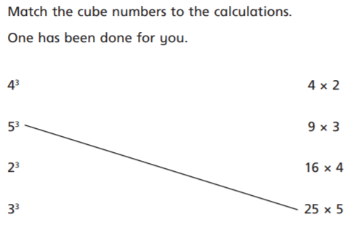

Drag the red lines to point to your answers!

