Thursday Maths Challenge
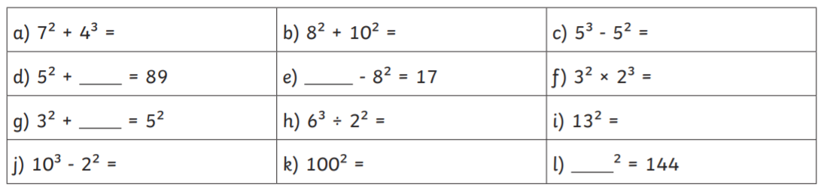
L.O: Cube numbers

