Wednesday Maths Challenge
L.O: Cube numbers

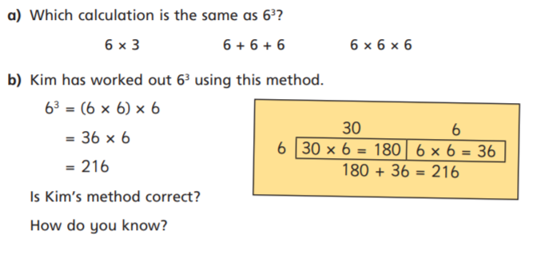
Answers:

