Tuesday Maths
L.O: Square numbers

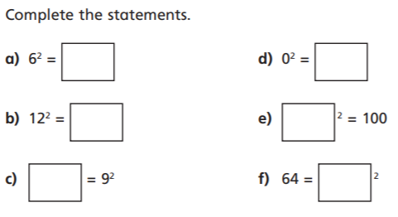

(you can click and write your answers in the boxes!)
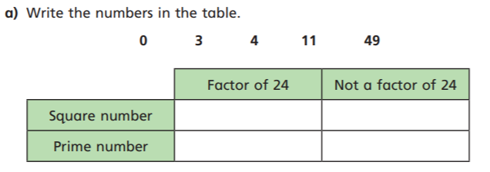

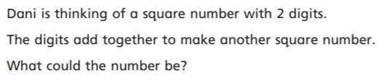
Answer:

