Monday
1. Ivan needs 240 football stickers to fill his magazine. Stickers are sold in packs of 60.
The shop only has 3 packs of stickers. Ivan buys all the packs of stickers available at the shop.
Has he bought enough stickers to fill his magazine? Prove it.
2. Match the children to the correct multiples of 6.
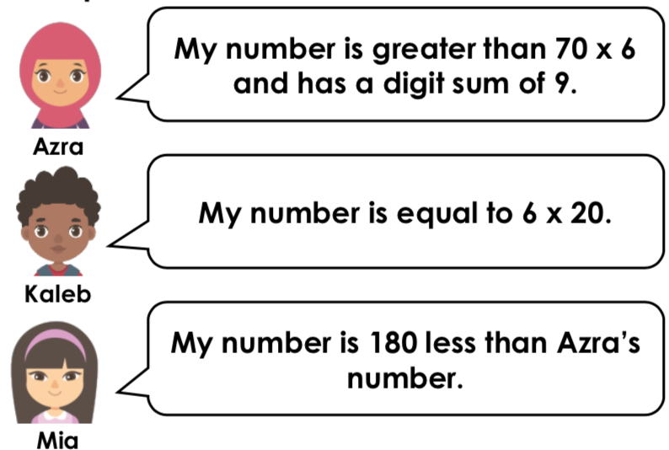
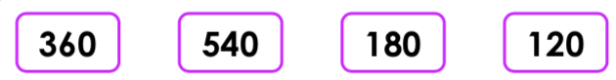

Tuesday
1. Lois makes an array with counters to represent the calculation 3 x 9 = 27.
She adds extra counters to show how she would calculate 4 x 9.
Find and correct her mistake.

2. Lexi and Dylan are comparing how many stickers they each have. Stickers are kept in packs of 9.
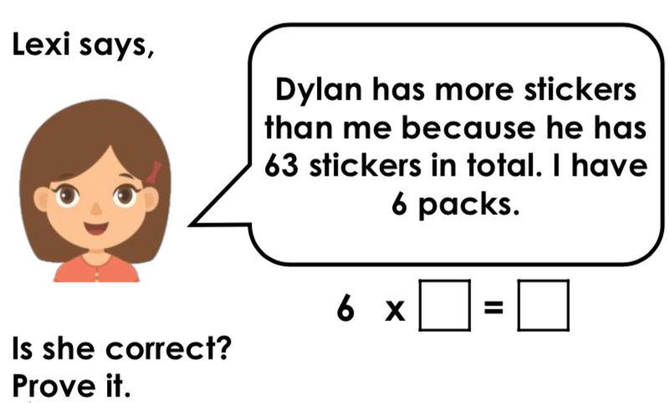

Wednesday
1. Use the numbers below to create four different calculations. Numbers may be used more than once.
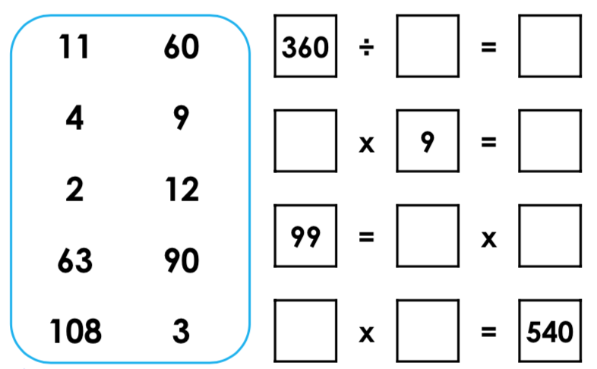
2. Emily says,
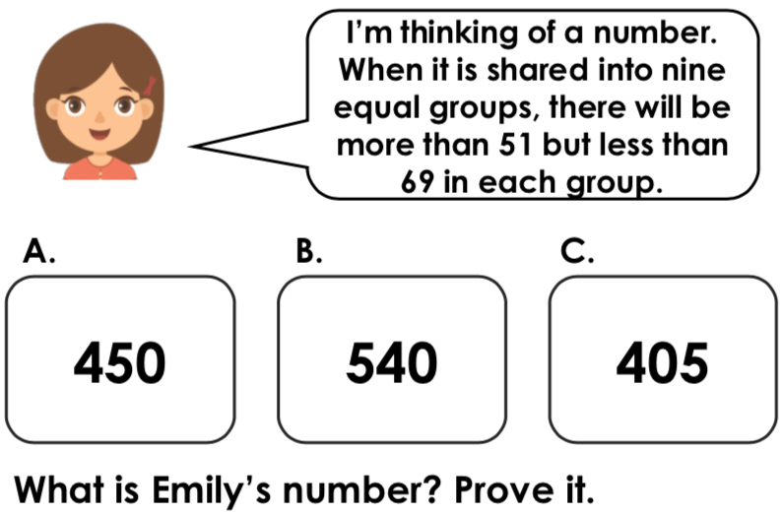

Thursday

1. Travel through the maze using only multiples of 7.
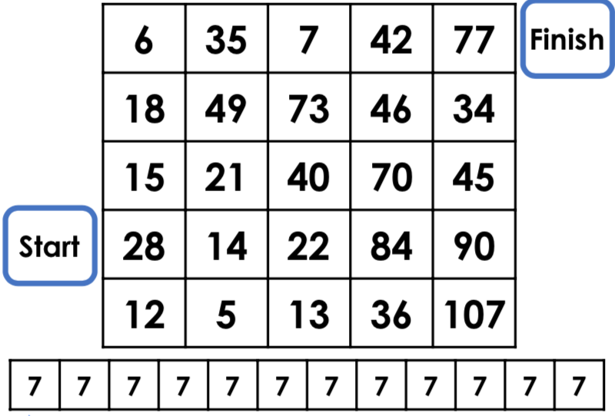
2. Which is the odd one out? Prove it.
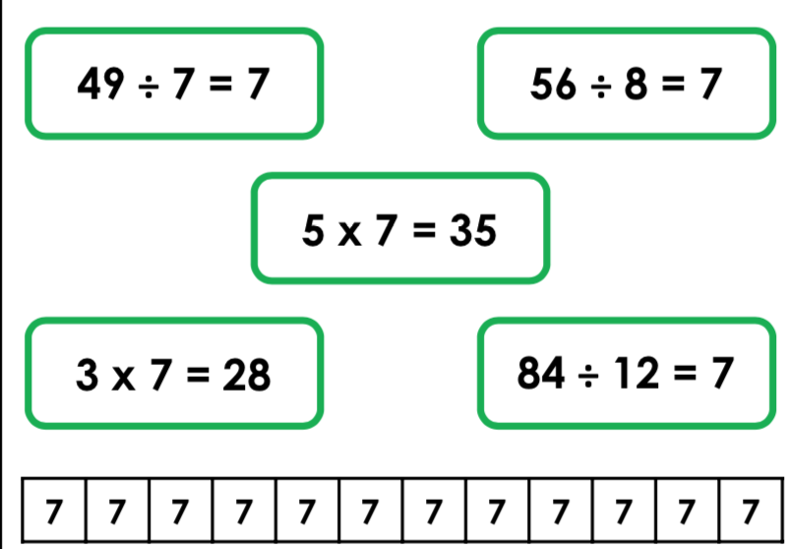

Answers
Monday Tuesday
1. No, Ivan has not bought enough stickers because 60 x 3 = 180. He needs 1 more packet.
2.
Ana – 540
Kaleb – 120
Mia – 360
1. Lois has added 3 counters which represents 10 lots of 3. She needs to add another row of 9 counters to represent the answer of 36.
2. Lexi is correct because she has 6 packs. 6 x 9 = 54 stickers. Dylan has 63 stickers, so he has more.

Wednesday Thursday
1. 28, 14, 21, 49, 35, 7, 42, 77

2.3 x 7 = 28 is the odd one out because it is incorrect. 28 is the fourth multiple of 7.

1. Various answers, for example: 360 ÷ 4 = 90; 12 x 9 = 108; 99 = 11 x 9 and 60 x 9 = 540.

2. Emily’s number is 540 (B) because 540 ÷ 9 = 60 and 60 is more than 51 but less than 69.

