Monday Maths
L.O: Square numbers

- Write all of the square numbers up to 12²
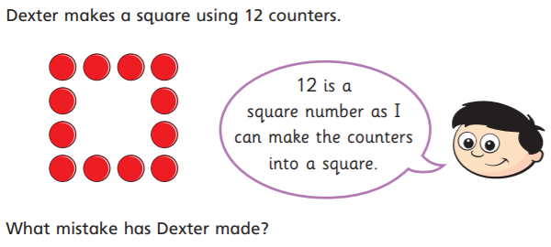

Answer:
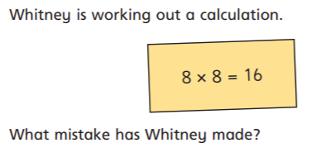

Answer:

