Monday Maths Challenge
L.O: Square numbers

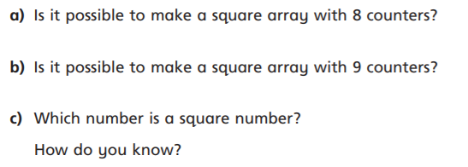

Answers:
a
b
c

