**Music**

Learn about timbre and body percussion, working through lesson 1

<https://classroom.thenational.academy/lessons/body-percussion-basics-69j30t?activity=video&step=1>

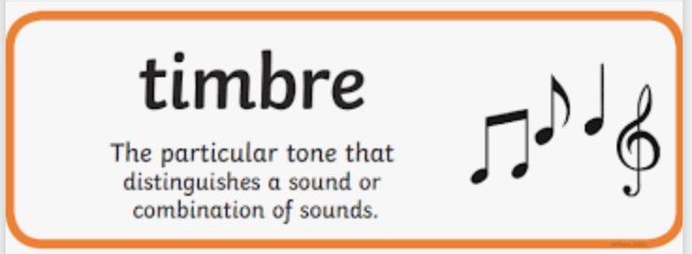

**Design Technology**

Design and make your own Roman artefact (depending on what resources you have at home). Here are some suggestions –

<http://www.lydgatejunior.co.uk/year-4/roman-chariots>

<https://www.google.com/search?q=roman+model+catapult+ks2&tbm=isch&ved=2ahUKEwiqntzw7ajuAhUWKhoKHfZbAiYQ2-cCegQIABAA&oq=roman+model+catapult+ks2&gs_lcp=CgNpbWcQA1CapAJYmqQCYJaxAmgAcAB4AIABaogBapIBAzAuMZgBAKABAaoBC2d3cy13aXotaW1nwAEB&sclient=img&ei=DEQHYKroG5bUaPa3ibAC&bih=800&biw=1280&client=safari&hl=en-GB>

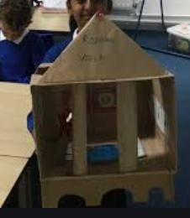

**PE**

### Watch the video from Lesson 19 -Throwing techniques

<https://www.afpe.org.uk/physical-education/thisispe-supporting-parents-to-teach-pe-at-home/> and try this at home.



.

**PHSE**

 how to respond proportionately to, and manage, feelings in different circumstances.

Complete the quiz to respond to feelings and emotions

<https://www.educationquizzes.com/ks2/personal-social-and-health-education/emotions-2/>

**Science** 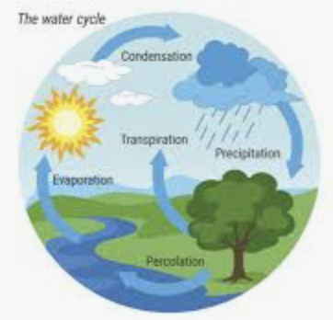

The Water Cycle

Watch the lesson on The Water cycle from Teams.

Draw your own diagram of the Water Cycle and write out the Water Cycle explanation, filling in the missing words.

**Computing**

Read through the changing images for different uses.pdf and watch the video. which shows six versions of the same image. Discuss:

* How were these changes made?
* Can you guess which tools might have been used in the editor?
* What effect do the changes have on the image?

Choose a scenario linked with a theme such as sppoky, love, fun, exciting, evil etc. Choose some illustrations and use a photo editing program, such as paint.net, to edit the images to fit a theme.

Class 4 activities

WB 25.01.2021



**French**

Watch lesson 1 video to learn the vocabulary

<https://www.lingotot.co.uk/EastDurham.html>

Complete the activities from the worksheet in your book.



# History - What were the key features of Roman towns?

# <https://www.bbc.co.uk/bitesize/clips/zq49wmn>

# <https://www.bbc.co.uk/bitesize/topics/zqtf34j/articles/ztqg4wx>

# <http://www.primaryhomeworkhelp.co.uk/romans/towns.htm>

# You have been asked to write a guide for visitors to your Roman town. You should include information about the amphitheatre, forum, shops, water supply, aqueduct, temple and bath houses. Give your town a Roman name.