Monday
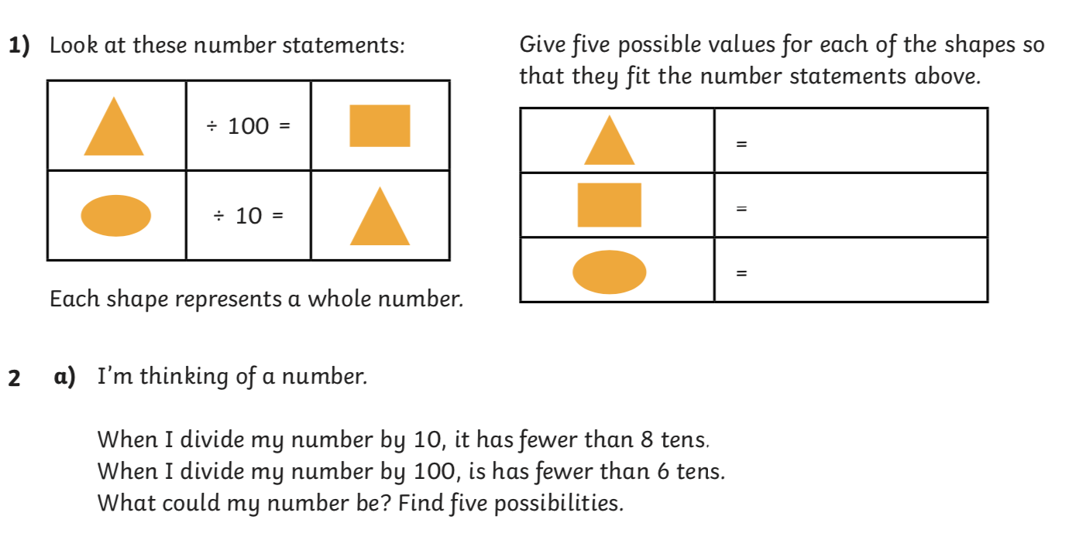
b) Can you create a mystery number problem like the one above for a friend to solve?

Answers below

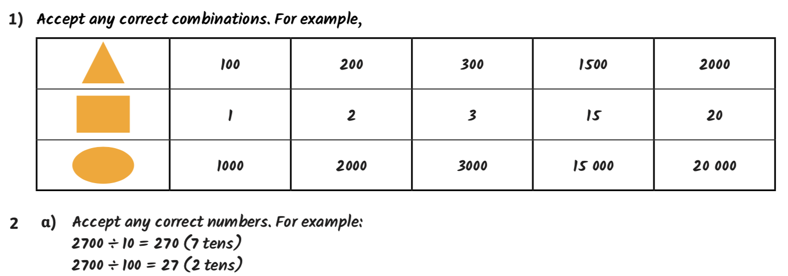

Tuesday

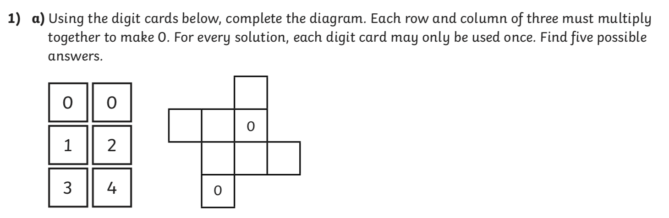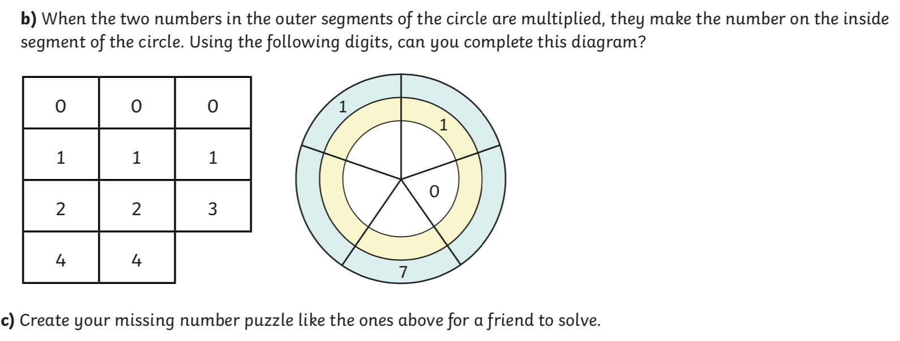

Answers Below

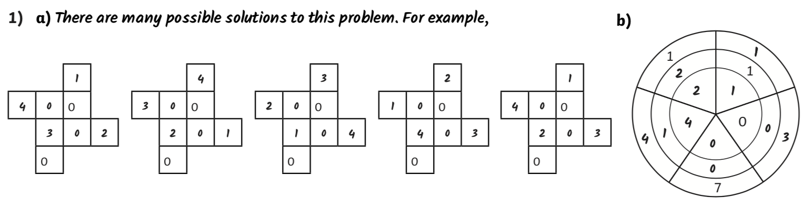
Wednesday

1. Cali is trying to work out the calculation below.
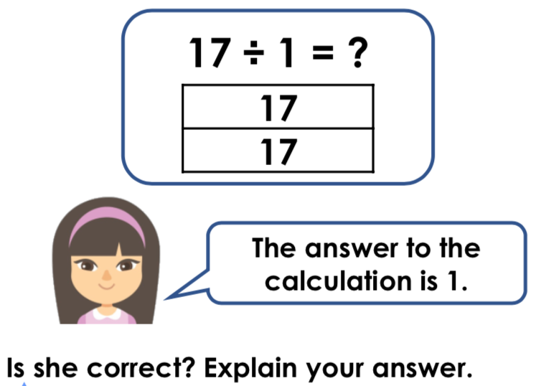

2. Mrs Smith has 5 pencils. She shares these out to each of the children below.
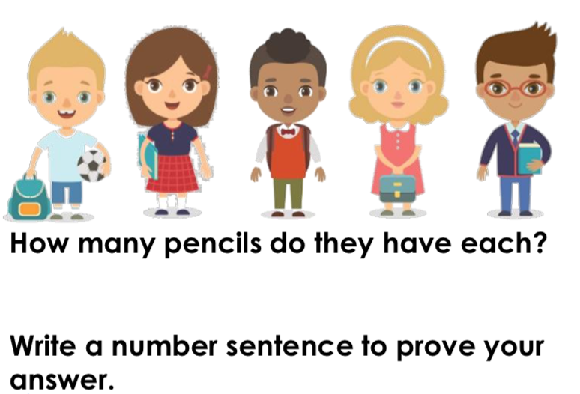
Thursday

1. Use the cards below to create as many calculations as you can.
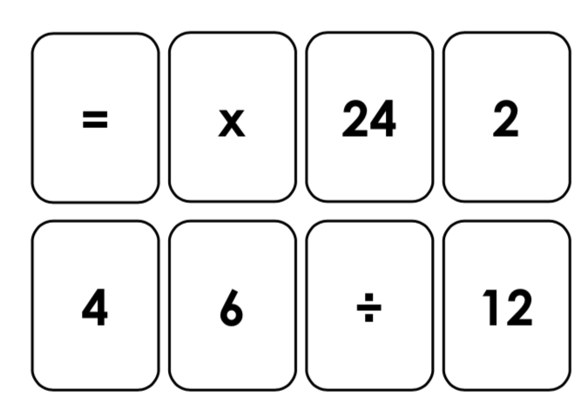

2. Max is trying to solve the calculation below.
