**Design Technology**



You are going to design a pizza for a purpose e.g. for a birthday party, for Easter, as a present. Complete your pizza design following the *pizza design* file.

**PE**

Watch the video from Lesson 18 – Reaction Wall

<https://www.afpe.org.uk/physical-education/thisispe-supporting-parents-to-teach-pe-at-home/>

and try this at home.

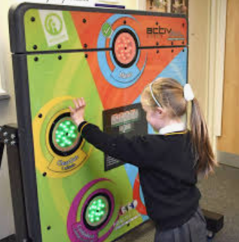

.

**French**

Find out about the rooms in your home and complete the online activities

<https://www.french-games.net/frenchlessons?topic=Home%20-%20rooms%20in%20the%20house&level=primary>

**PHSE**

<https://www.youtube.com/watch?v=_RqoU-m8kaw>

Feelings are often described as similes or metaphors and discuss their meaning, for example: feeling blue, over the moon etc. Complete the activity from *expressing feelings* file.

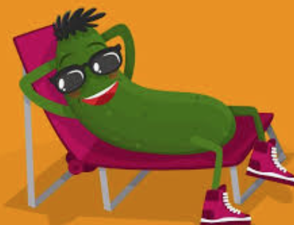



# History - What was life like in the home of a rich Roman?

Read through the *Roman homes* file to find out how rich Romans lived. You are going to be a Roman estate agent and create an advert for a Roman house for sale. Look at some examples of properties for sale in your area to help give you ideas. Remember to make it colourful and interesting to catch buyer’s attention.

**Computing**

Read through the *changing composition* file to learn how to make your own composition

Using a photo editing tool such as

paint.net ([www.getpaint.net](https://www.getpaint.net/" \t "_blank)),

BeFunky app ([www.befunky.com](https://www.befunky.com/" \t "_blank)), LunaPic ([www341.lunapic.com/editor](https://www341.lunapic.com/editor/" \t "_blank))

Take a photo of yourself and edit a Roman soldier image to place your face on it.

**Science**

Heating and Cooling

<https://www.bbc.co.uk/bitesize/topics/zkgg87h/articles/z9ck9qt>

Work through the online lesson to learn about heating and cooling and their effects on matter.

<https://classroom.thenational.academy/lessons/what-happens-when-you-heat-or-cool-each-state-of-matter-68w3at>

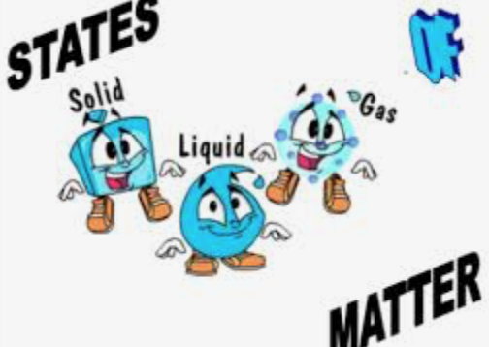

**Music**

Learn about Pulse and rhythm

<https://www.bbc.co.uk/bitesize/topics/zcbkcj6/articles/z2mqw6f>

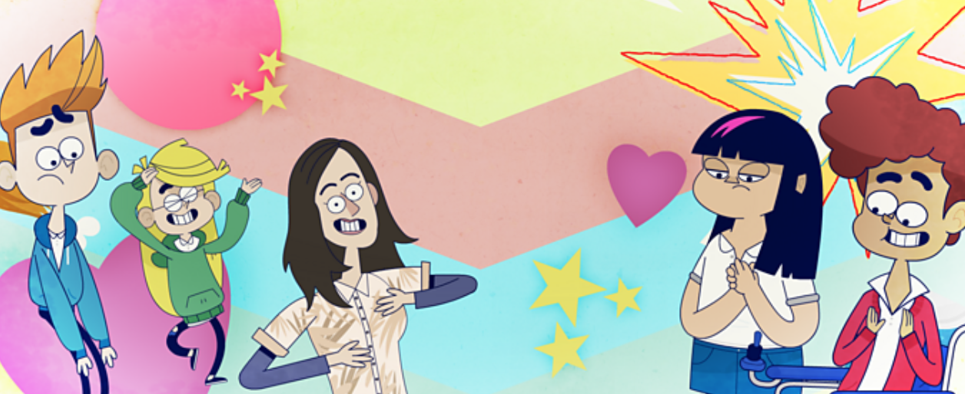

Class 4 activities

WB 18.01.2021

