**PE**

Dance along to the actions in this Just Dance video.

<https://www.youtube.com/watch?v=0W-T4kdgzKU>

Do it a few times to improve your technique.

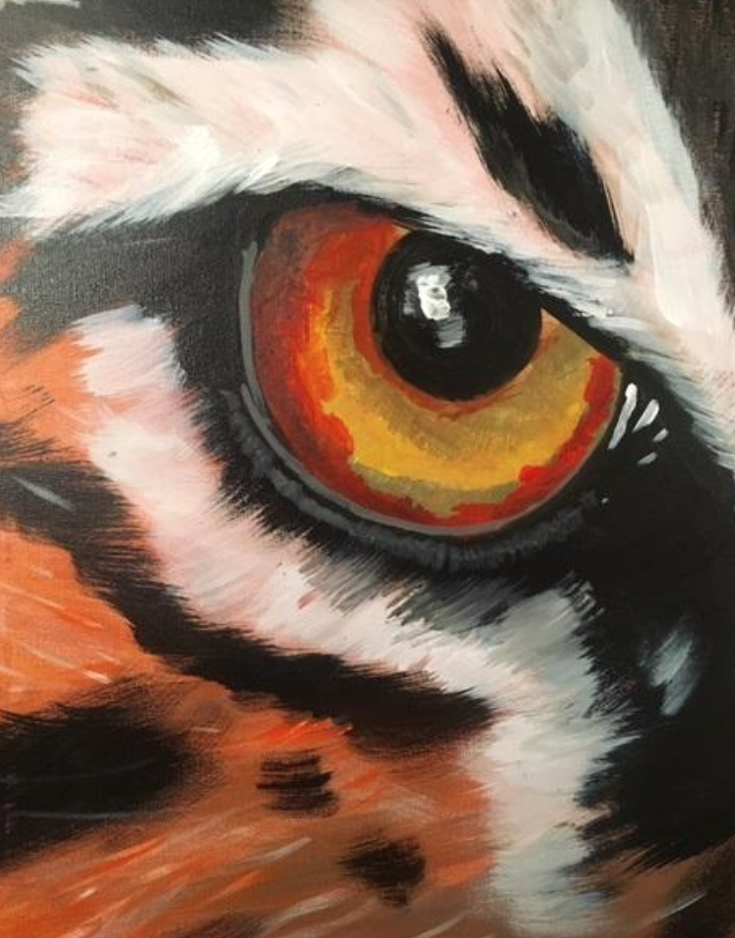

.

**Design Technology**

Carry out some research about pizza. Complete the answers from ***Pizza research.pdf*** and draw and label your favourite pizza.



**French**

Select **Place** from the menu, then **Place- homes** to work through the tutorial, activities and games on different types of homes in French.

<https://www.french-games.net/frenchtopics>

**PHSE**

Watch the video about emotions <https://www.bbc.co.uk/teach/class-clips-video/pshe-ks2-the-brain-house/zd7kd6f>

**Complete activity *myFeelings.pdf***

Think about which feelings you have most and least often. Write down some times when you feel happy and why they make you happy.

**Science**

Investigate gases and explain their properties.

Read about gases and their properties.

<https://www.dkfindout.com/uk/science/solids-liquids-and-gases/gases/>

<https://www.factmonster.com/dk/encyclopedia/science/gases>

Complete the fact file about gases – ***It's a gas.pdf*** using the information you found about gases.

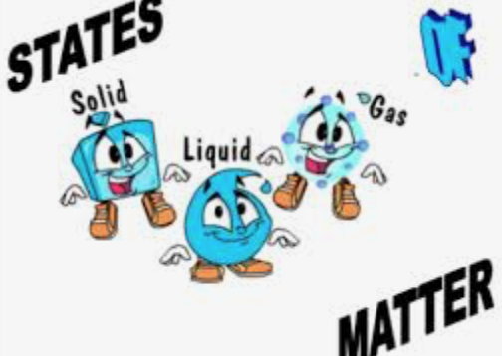

**Music**

Watch the live performance of Suspicious minds

<https://www.youtube.com/watch?v=Y_RCvsiavuM>

Answer the questions from ***Music 11.01.2021*** about the song and find out more about Elvis.

# History - What was it like in Roman Britain?

# Read about life for Romans and complete the activities

[**https://www.bbc.co.uk/bitesize/topics/zqtf34j/articles/ztqg4wx**](https://www.bbc.co.uk/bitesize/topics/zqtf34j/articles/ztqg4wx)

[**https://bam.files.bbci.co.uk/bam/live/content/zwh7xnb/transcript**](https://bam.files.bbci.co.uk/bam/live/content/zwh7xnb/transcript)

<https://www.historyforkids.net/roman-daily-life.html>

Write a diary about a day in the life of a Roman living in Britain. Think about – what you would wear, what you might eat, what you would do, where you might go, what you would do for entertainment, who else is in your home?

**Computing**

Work through the ***photo editing.pdf*** to find out about editing images. Then have a go at editing one of the images in ***images.pdf***.

Can you crop an image?

Change the image to greyscale?

Edit the image to remove part of it?

Class 4 activities

WB 11.01.2021

