**PE**

Dance along to the actions in this Just Dance video.

<https://www.youtube.com/watch?v=bMZAuhadz2Y>

Do it a few times to improve your technique.

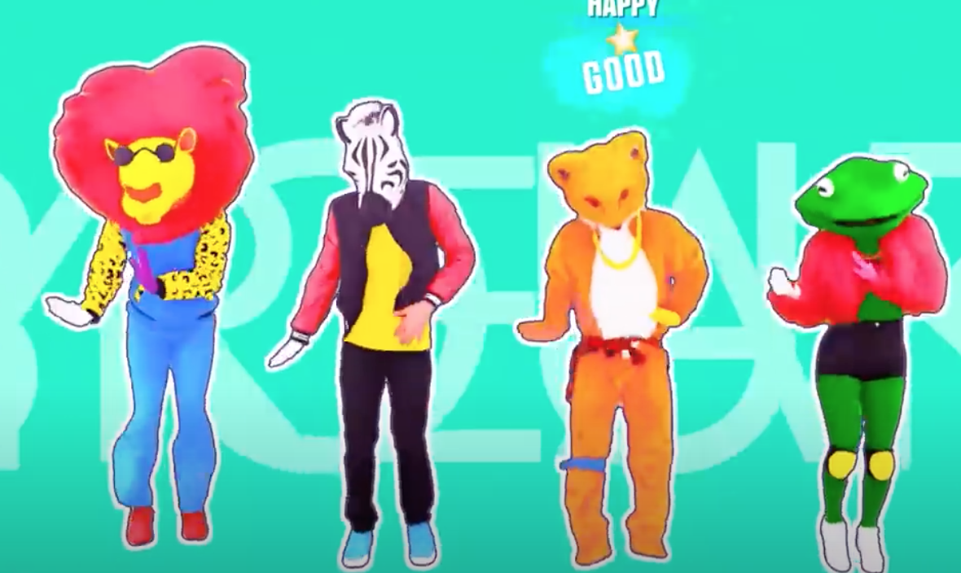

.

**Design Technology**

Read the information about Italian food and complete your own Italian Restaurant menu.



**French**

Work through the tutorial and activities to learn to talk about where you live in French

[**https://www.french-games.net/frenchlessons**](https://www.french-games.net/frenchlessons)



**PHSE**

Use Resource 1 Ziggy’s Day. Can you think of how Ziggy might be feeling at each point in the day and why?



**History**

**When were the Romans in Britain and how do we know?**

[**https://www.bbc.co.uk/bitesize/clips/zq49wmn**](https://www.bbc.co.uk/bitesize/clips/zq49wmn)

In Britain, lots of places have Roman endings such as ‘caster’ meaning fortified camp and ‘chester’ meaning there was a fort or town in that place such as Manchester and Lancaster. Use a map of the UK to find as many other place names ending ‘chester’ and ‘caster’ as you can.

**Computing**

Develop your programming skills by completing challenges 1 and 2

<https://www.transum.org/software/Logo/>

Try challenge 3 if you feel confident.

**Science**

Watch the video to find out about states of matter <https://www.bbc.co.uk/bitesize/topics/zkgg87h/articles/zsgwwxs>

Using Science worksheet WB04 Jan, can your sort the materials into solids, liquids and gases and complete the information about their properties.

Now, sing and dance along with the song.

<https://www.youtube.com/watch?v=3IW8E1YR0kE>

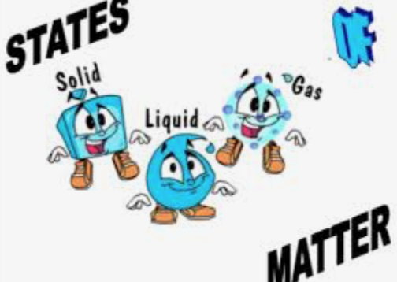

**Writing**

Write the story using Resource 1: Ziggy’s day from PHSE lesson to describe Ziggy’s experiences and explain why Ziggy feels like that at different times of the day. Imagine you are telling a younger brother or sister the story.

Remember to use paragraphs and connect your ideas using fronted adverbials, i.e. Later that day,…At lunchtime, … When he got up, …

Class 4 activities

WB 04.01.2021

