Keeping safe: no matter what the weather is like!

Sunny weather days often take us by surprise during this term – sometimes starting off cold at the start of the day and then heating up quickly by playtime. Please help us keep your children safe by ensuring that they are wearing a cap and have sun cream on to protect them during outdoor times. At the same time – could you please make sure your child has a jumper or cardigan (labelled with their name) in case it turns a little colder.

Please also ensure that your child has a water bottle so that they can stay hydrated throughout the day.

Homework

Homework will look a little bit different this year and during this term we will be focussing on basic skills in both Maths and English. Details of this will follow in the upcoming weeks.

Due to Covid 19 restrictions reading books will not be sent home and we will continue to follow government guidance on this line. We will be continuing to use the online reading resources from Oxford Owl and we ask that you read the book(s) with the children as often as you possibly can. Thank you. <https://www.oxfordowl.co.uk/>

PE/ Outdoor Learning

P.E. takes place on a Wednesday and Friday. We ask that the children come to school in their PE/ outdoor learning kit which includes their school jumper. We are very lucky this year to have Scout-Ed on a Wednesday taking our learning outside. During these Wednesday sessions we be learning to become more resilient, independent and critical thinkers, sometimes our learning will be messy so we ask that your children come to school dressed in suitable warm clothing that you won’t mind getting messy e.g an old tracksuit and wellies. Please can you make sure that all of your child’s belongings are clearly labelled.

If you have any queries, please feel free to email me on [y.harker300@durhamlearning.net](mailto:y.harker300@durhamlearning.net) . Many thanks.

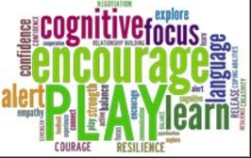

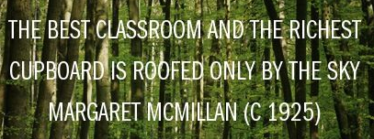

Our Lady of Lourdes R.C. Primary School

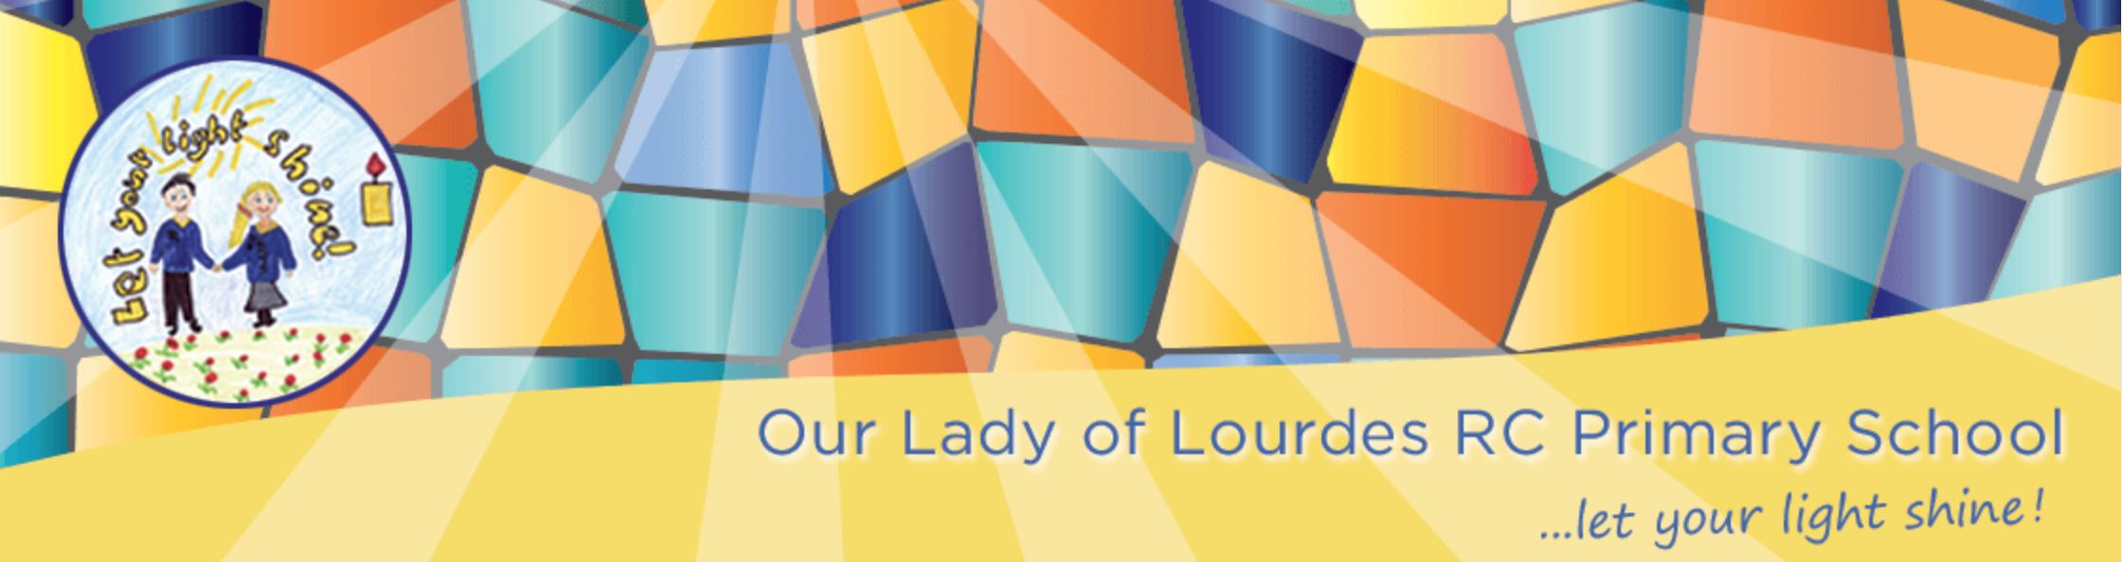

Year 2 Newsletter

Autumn Term

Welcome back to a new school year. This year has been a very unusual year for everyone and we would just like to say thank you for how supportive and fabulous you and your children have been over the past few months. In Year 2 your teacher will be Miss Harker and TA will be Mrs Guy. We hope that you all had a safe and relaxing Summer holiday.

As we start our new school year we will be placing great emphasis on the children’s health and well-being. We will be completing lots of get to know you tasks during our PSHE sessions and helping minimise and worries that your child may have about the new school year.

Our class newsletter will let you know what is happening throughout your child’s first term in Year Two.

Your child’s teachers are: Miss Jewitt, Mrs Lamb and Mrs Weatherill. We look forward to working in partnership with you.

On a Friday XXXX

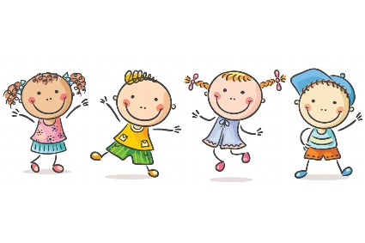

**Maths**: We will be focusing on our key skills in maths such as place value within numbers to 100 and number bonds to 10,20 and 100. Comparing numbers up to 100, reading and writing numbers to 100 in numerals and words. We will begin to skip count in 2’s, 5’s, 3’s and 10’s. We will develop our understanding of addition and subtraction using one- and two-digit numbers. During this term we will use our understanding of money to complete a variety of number sentences and count different units. Using all of these we will grow and develop our resilience and problem-solving skills whilst completing different challenges.

**Science**: We will learn all about a variety of different materials and their uses working scientifically to come to conclusions about the suitability of different materials for Durham Cathedral and other special places.

**History**: Our topic is learning all about a variety of special places and how these places are special. Placing these onto a timeline of when they were built. Learning a range of vocab relating to the past such as century, recent and long age. We will learn about timelines – starting with the children’s own timeline. We will also learn how Christmas was celebrated in the past.

**DT**: We will be designing and creating our own Special place based on the many special places we will look at including the Angel of the North.

**Art**: As artists we will be looking at a selection of the works of the Sculptor Antony Gormley and the architect Sir George Gilbert Scott. Looking at form and line used in these buildings and sculptures, creating our own 3D sculpture.

**Computing**: We will recognise the importance of keeping safe online. We will begin to understand that algorithms are implemented as programmes on digital devices. We will use Beebot to match animal cards, identify families of animals and make routes using precise instructions using sets of arrow cards to make instructions.

**Geography**: We will be looking closely at our wonderful world and what makes up the amazing place we live. Looking at simple world maps and identifying the features of the world.

**Music**: We will be focusing on listening in our music lessons using animal songs and rhymes. Whilst exploring the world we will listen to the many sounds the world creates.

**English**: We will continue to build up our phonic skills with **daily** phonic sessions. Perhaps the children could point to and show you some when reading at home with you! We aim to continue to foster a love of reading in Year Two – where children want to learn to read for information as well as enjoyment and pleasure. Our key reading opportunities this term will be based on a selection of poems, fiction and non-fiction books related to new beginnings and special places‘’. We will also be sharing a number of novels together as we read at the end of the school day, During our writing we will be firstly focussing on key skills whilst composing and writing sentences: thinking about what our sentence/sentences will be; sitting comfortably at the desk; leaving finger spaces; trying to keep on the line; listening to the sounds; using capital letters and full stops; trying to form letters correctly and reading the sentence after – to check that it makes sense.

**Religious Education**: In R.E. we will be learning about:

Beginnings**.** *Suggestions for home activities:*  * Think about new beginnings such as the new school year and how they feel about this.

Talk about why some beginnings are easy and some are difficult.

**Signs and Symbols.** *Suggestions for home activities:*  * Spot different signs whilst they are at home/ out. E.g. toilets, McDonald’s ect.

Talk about the different symbols shared in our lives. E.g. hug, shake hands, smile

**Preparations.** Suggestions for home activities:  **\***Can you think of a time that as a family you have had to prepare for something? *E.g. a holiday, a visit from a special relative, starting school, Christmas etc.*

*We will learn in class about Advent being a time when we prepare for Christmas – ask the children to think about what you as a family to prepare for Christmas e.g put the decorations up, send Christmas cards etc.