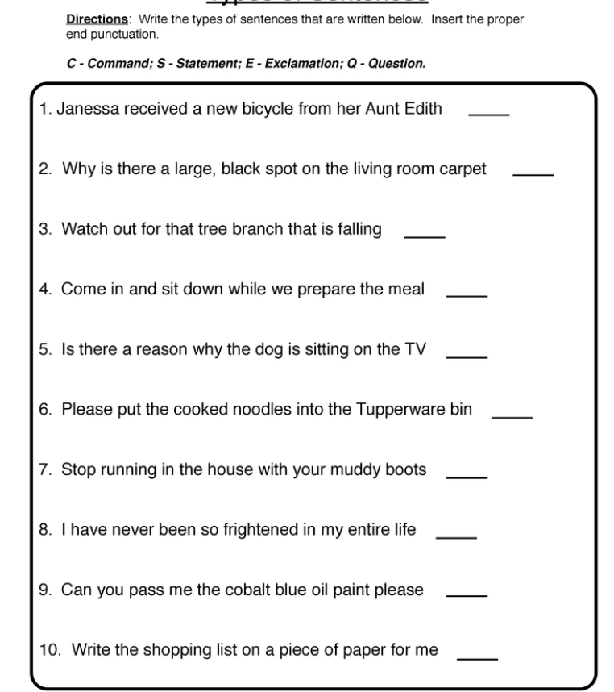

Challenge
Using the picture below, can you write:
One statement
One Question
One Command
One Exclamation

Answers
- Janessa received a new bicycle from her Aunt Edith. (S)
- Why is there a large, black spot on the living room carpet? (Q)
- Watch out for that tree branch that is falling! (E)
- Come in and sit down while we prepare the meal. (C)
- Is there a reason why the dog is sitting on the TV? (Q)
- Please put the cooked noodles in the Tupperware bin. (S)
- Stop running in the house with muddy boots. (C)
- I have never been so frightened in my life! (E)
- Can you pass me the cobalt blue oil paint please?(Q)
10.Write the shopping list on a piece of paper for me. (C)

