Reasoning and Problem Solving – Multiply by 7

.
1. Which is the odd one out? Prove it.  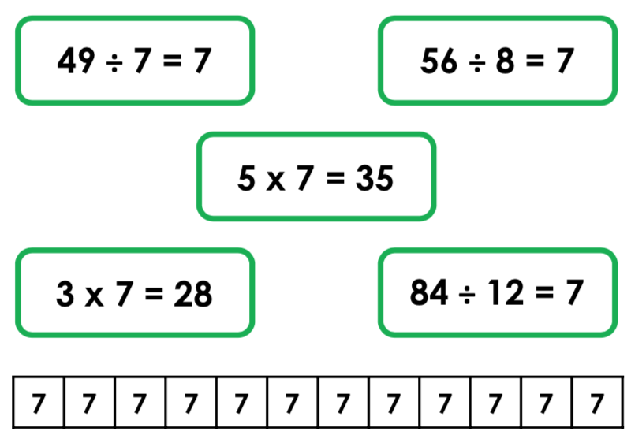 | 2. Which is the odd one out? Prove it.  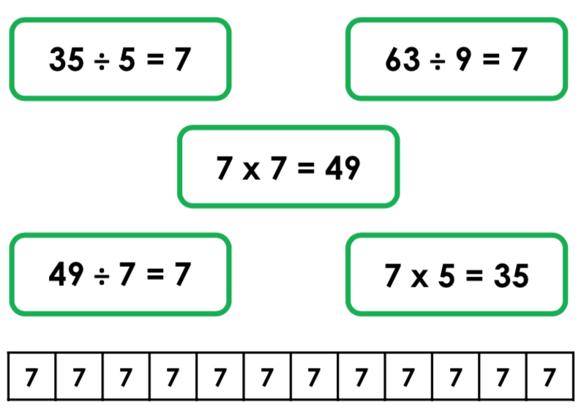
3. Travel through the maze using only multiples of 7.  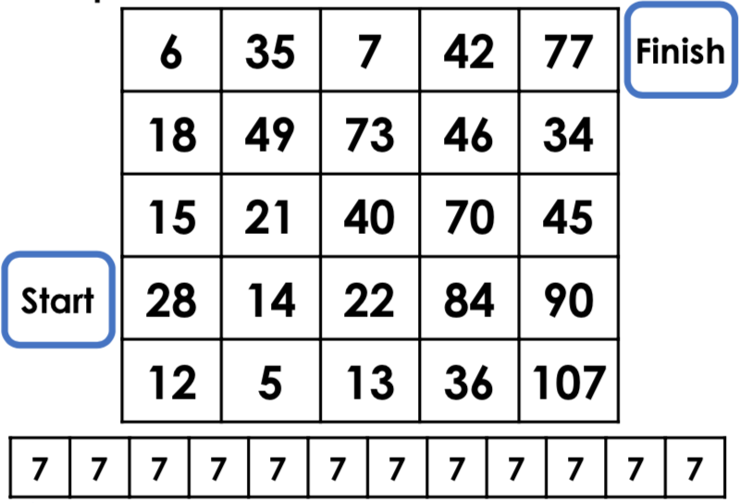 | 4. Travel through the maze using only multiples of 7.  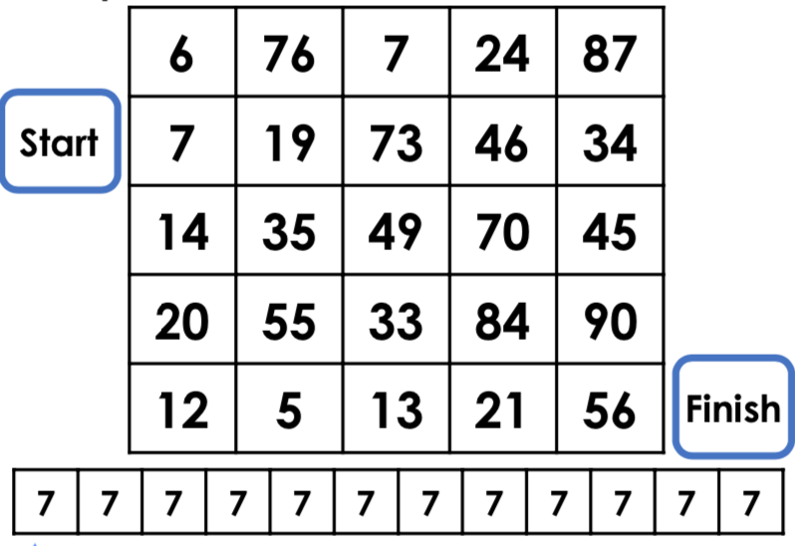
5. Write a word problem for each of the following calculations.  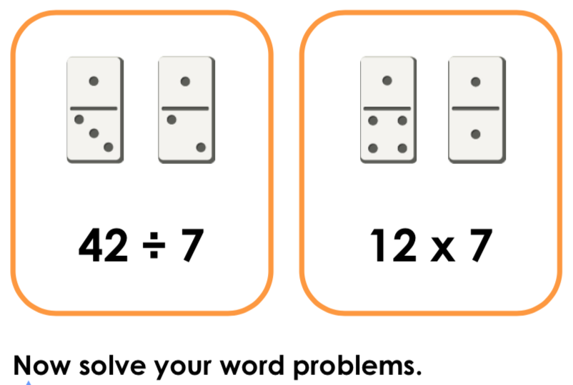 | 6. Write a word problem for each of the following calculations.  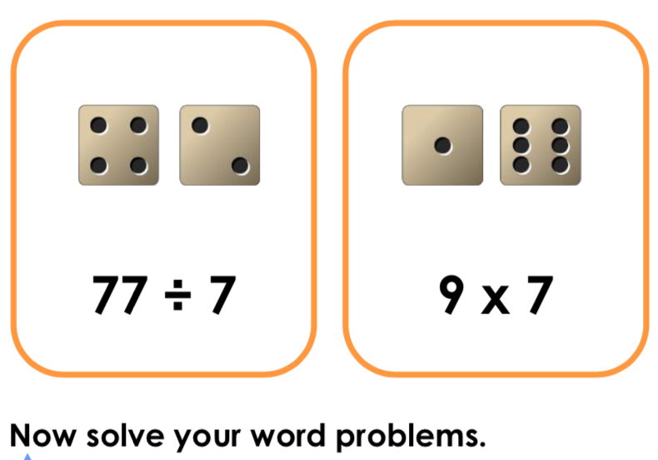

7. Match the statements to the correct totals.

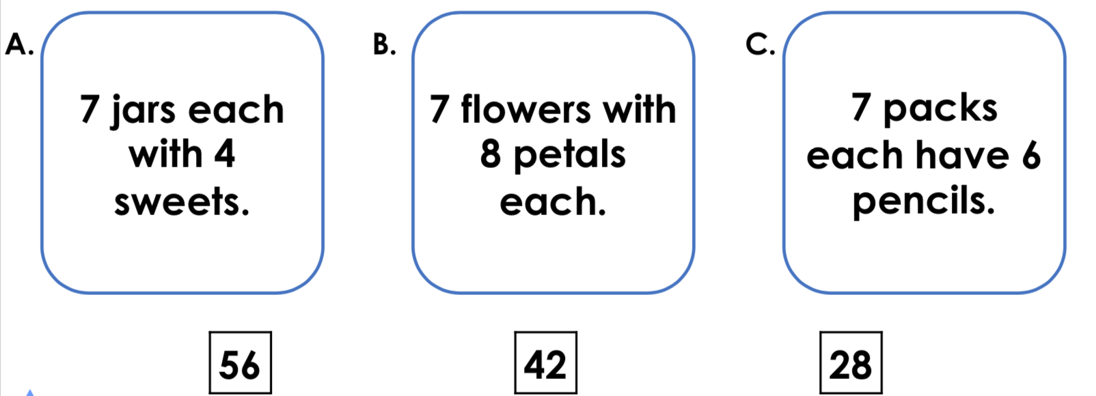

8. Lucy visits the pet shop to buy some fish for her new tropical tank. She says,

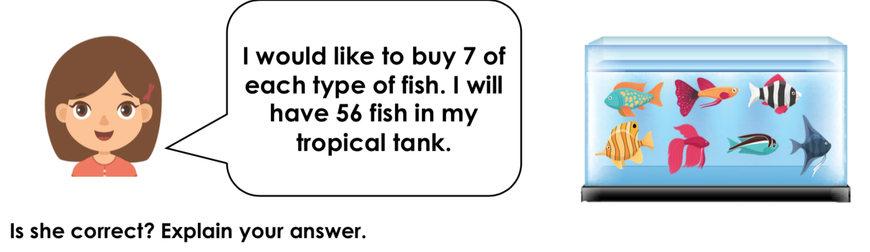

Answers
1. 3 x 7 = 28 is the odd one out because it is incorrect. 28 is the fourth multiple of 7.
2. 63 ÷ 9 = 7 is the odd one out because the other two division calculations can be paired with a multiplication, e.g. 49 ÷ 7 = 7 and 7 x 7 = 49
3. 28, 14, 21, 49, 35, 7, 42, 77
4. 7, 14, 35, 49, 70, 84, 21, 56
5. Various answers, for example: Jeremy has 42 flowers that must be sold in bunches of 7. How many bunches does he have to sell? 42 ÷ 7 = 6. Kyla buys 7 packs of stickers. Each pack has 12 stickers in it. How many stickers does she buy in total? 12 x 7 = 84.
6. Various answers, for example: 7 footballers have a total of 77 shots on goal. How many shots do they have each? 77 ÷ 7 = 11. I bought 7 packs of sweets. Each pack has 9 sweets in it. How many sweets do I have in total? 9 x 7 = 63.
7. A. 28; B. 56; C. 42
8. No, she is not correct. 7 x 7 = 49.

