Reasoning and Problem Solving – Multiply by 9
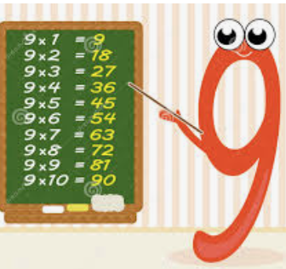

.
1. Lois makes an array with counters to represent the calculation 3 x 9 = 27.  She adds extra counters to show how she would calculate 4 x 9.  Find and correct her mistake. | 2. Liam makes an array with counters to represent the calculation 2 x 9 = 18.  He removes some counters to show how he would represent 1 x 9 = 9.  Find and correct his mistake.
3. Sue is filling boxes with buns. She can put 9 buns in each box and each box is full. 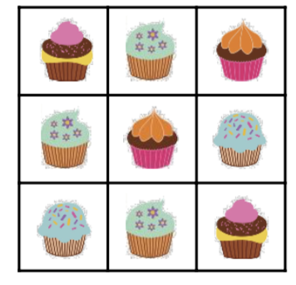  Sue has between 50 and 75 buns. How many boxes might she need? | 4. Josh is packing crates with bottles of pop. He can put 9 bottles in each crate and each crate is full.  Josh has used between 9 and 12 crates. How many bottles might he have packed?
5. Lexi and Dylan are comparing how many stickers they each have. Stickers are kept in packs of 6.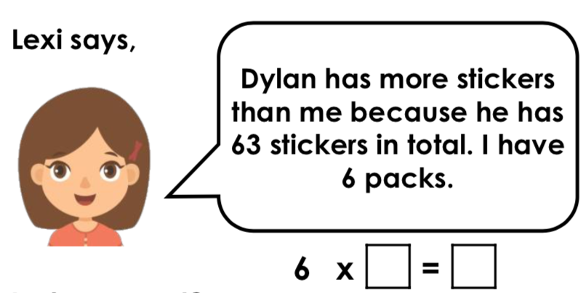  Lexi says,  Is she correct? Prove it. | Harry and Maisie are sharing out some strawberries for their class. There are 9 strawberries in each bowl. 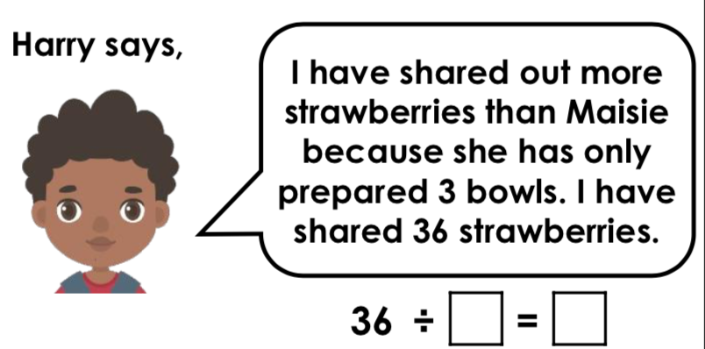Harry says,  Is he correct? Prove it.  I have shared out more strawberries than Maisie because she has only prepared 3 bowls. I have shared 36 strawberries.
7. Hassan says,  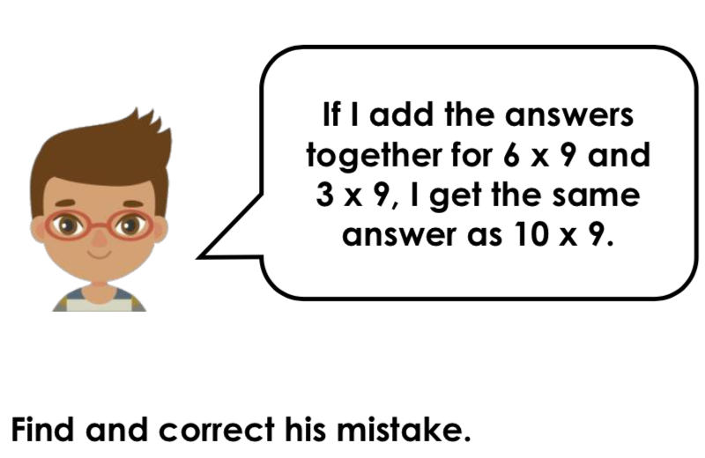 | 8. Jim and Kat are sharing game cards with their friends at their after-school club. There are 9 game cards in each pack.  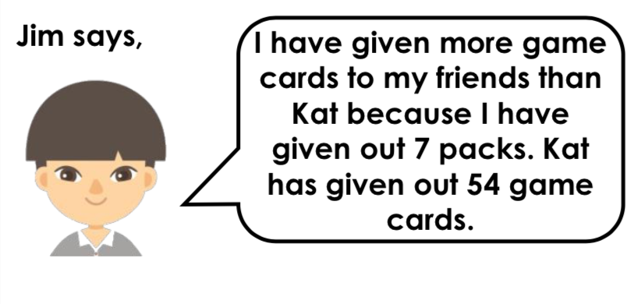

Answers

1. Lois has added 3 counters which represents 10 lots of 3. She needs to add another row of 9 counters to represent 4 x 9 to represent the answer of 36.
2. Liam has removed the correct number of counters but he has arranged them to represent 3 x 3 = 9. He needs one row of 9 counters to represent 1 x 9 = 9.
3. Sue could have 54, 63 or 72 buns. She might need 6 (54 ÷ 9 = 6), 7 (63 ÷ 9 = 7) or 8 (72 ÷ 9 = 8) boxes.
4. Josh could have used 9, 10, 11 or 12 crates. He might have packed 81 (9 x 9 = 81);90(10x9=90);99(11x9=99)or108 (12 x 9 = 108) bottles of pop.
5. Lexi is correct because she has 6 packs. 6 x 9 = 54 stickers. Dylan has 63 stickers, so he has more.
6. Harry is correct because he has shared out 36 strawberries. 36 ÷ 9 = 4 bowls. Maisie has prepared 3 bowls which is fewer than Harry’s 4 bowls.
7. Hassan’s calculation would be: 6 x 9 = 54 and 3 x 9 = 27 54 + 27 = 81 or 6 + 3 = 9 x 9 = 81 which is not equal to 10 x 9 = 90.
8. Jim is correct because Kat has given out 6 packs. 54 ÷ 9 = 6. Jim has given out 7 packs which is more than Kat.

