Activity 2 – Multiply by 7
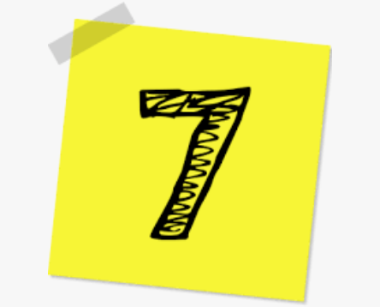

1. Create 2 calculations using the digit cards and symbol.  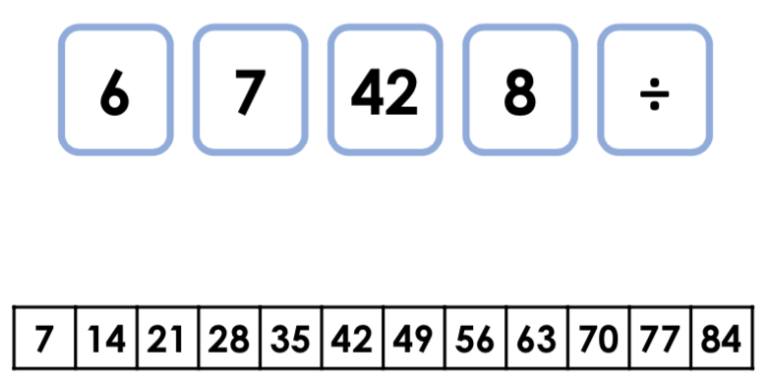 | 2. Create 2 calculations using the digit cards and symbol.  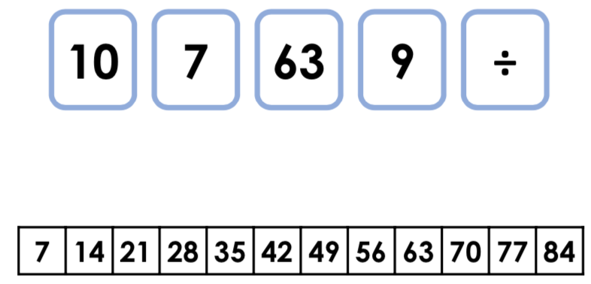
3. Complete the statement below.  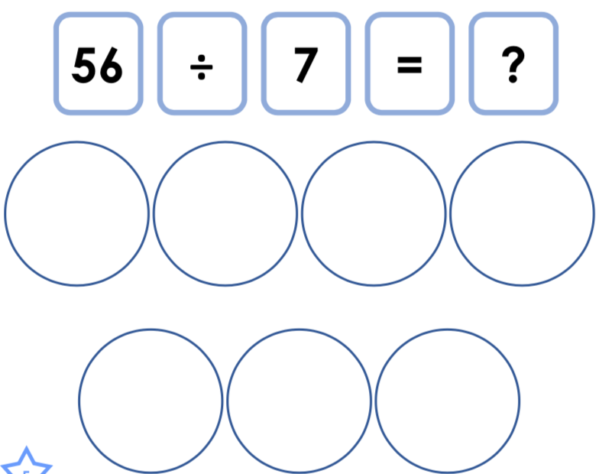 | 4. Complete the statement below.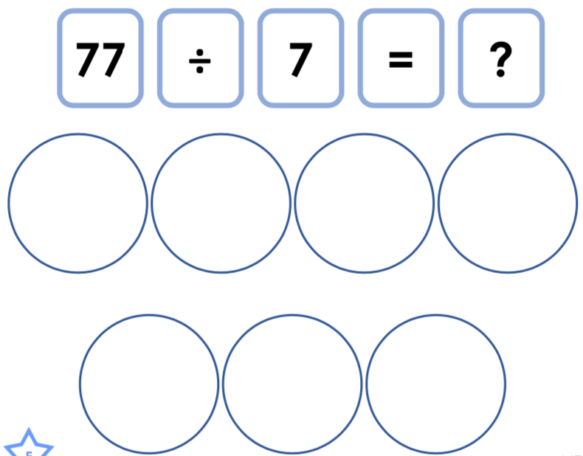
5. Complete the part-whole model below.  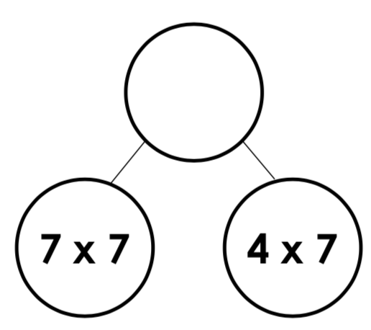 | 6. Complete the part-whole model below.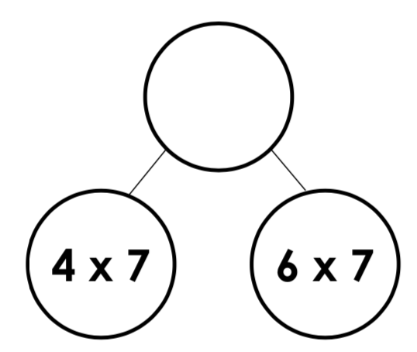

7. Complete the division circle by dividing the outer numbers to fill in the gaps.

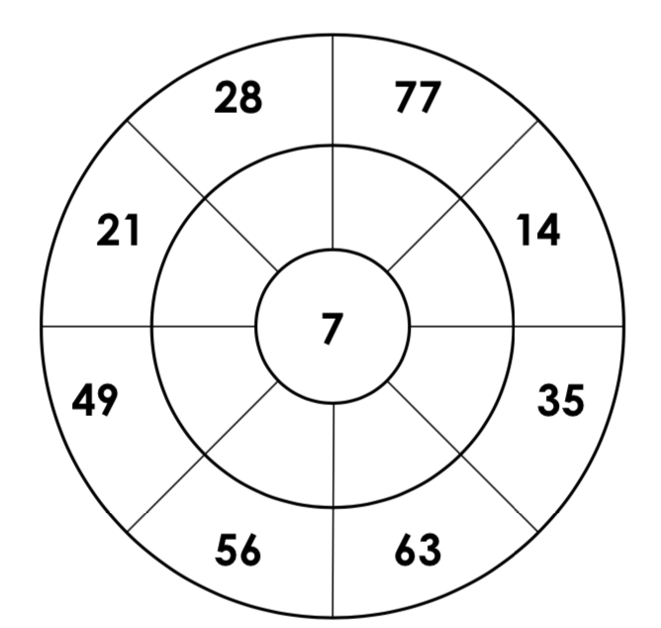

8. Complete the multiplication and division circle.
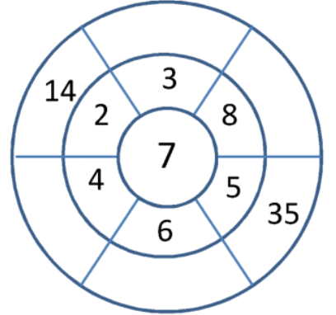

Answers

1. 42 ÷ 7 = 6 and 42 ÷ 6 = 7
2. 63 ÷ 7 = 9 and 63 ÷ 9 = 7
3. 56 ÷ 7 = 8
4. 77 ÷ 7 = 11
5. 77
6. 70
7. 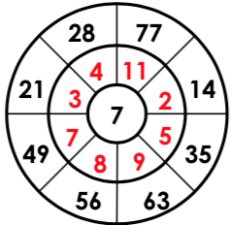
8.
