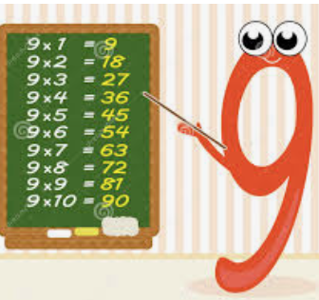 Activity 2 – Multiply by 9

1. Write a multiplication and a division calculation based on the bar model.  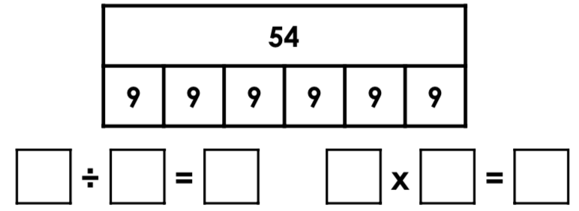 | 2. Write a multiplication and a division calculation based on the bar model.  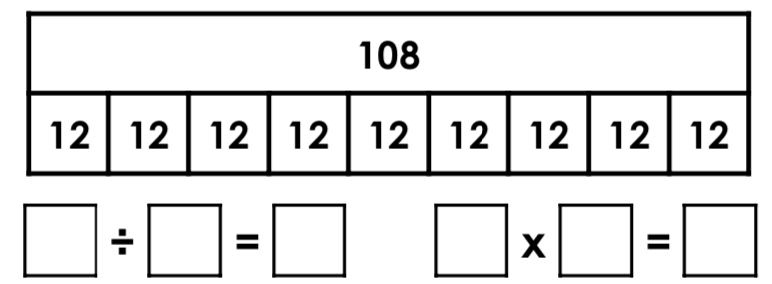
3. Using the image below, complete the number sentences.

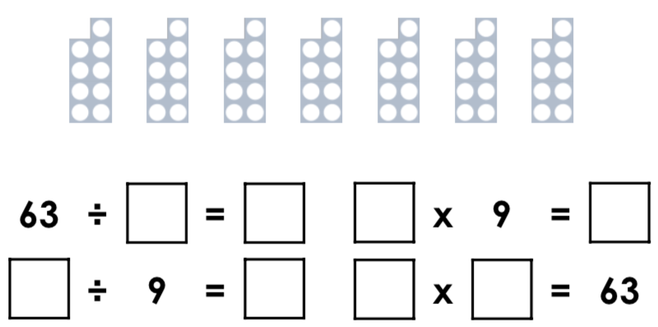
4. Using the image below, complete the number sentences.
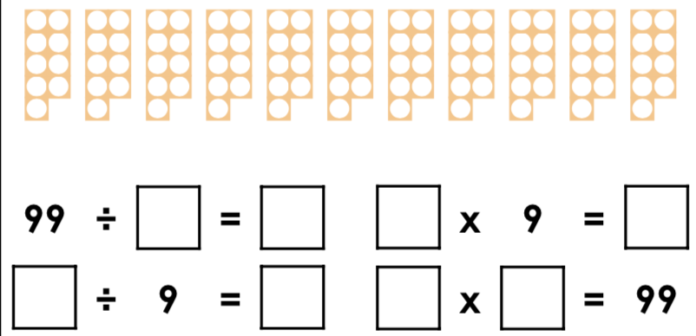
5. Naomi is thinking of a number. Fay thinks she knows the answer.
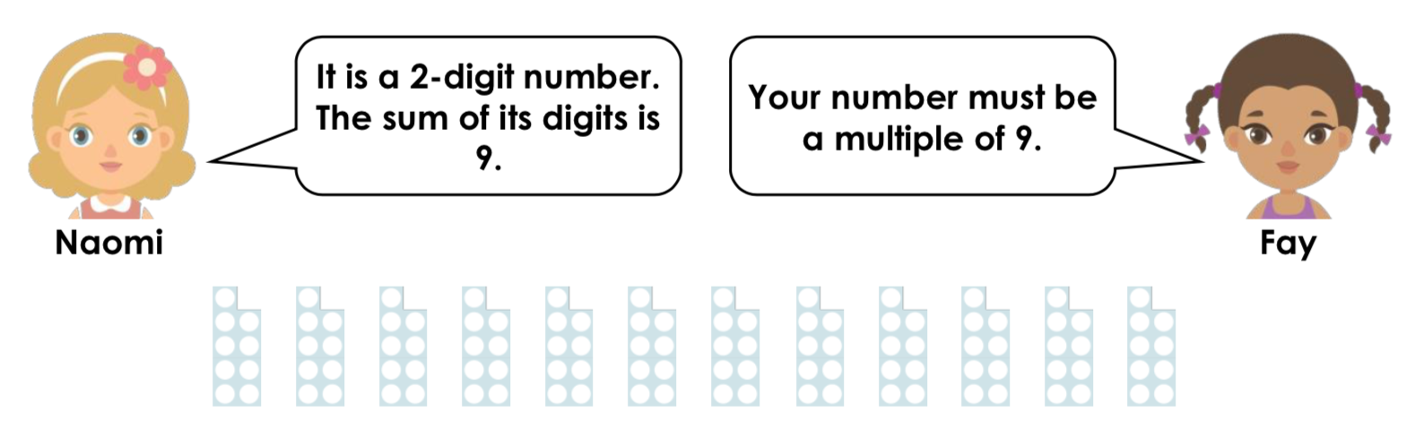
Is Fay correct? Convince me.

6. Circle the number sentences that are represented by the array.  . 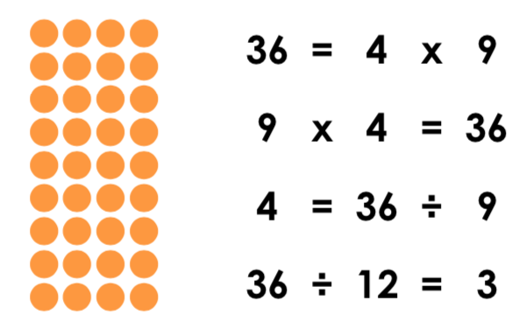 |  | 7. Use the sentences to complete the calculations.  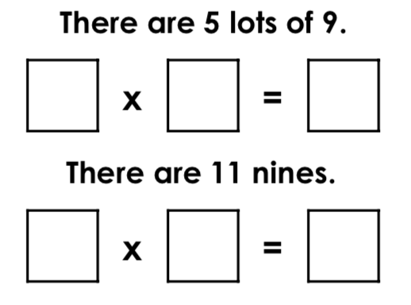
8. Using the first calculation, complete the number sentences below.
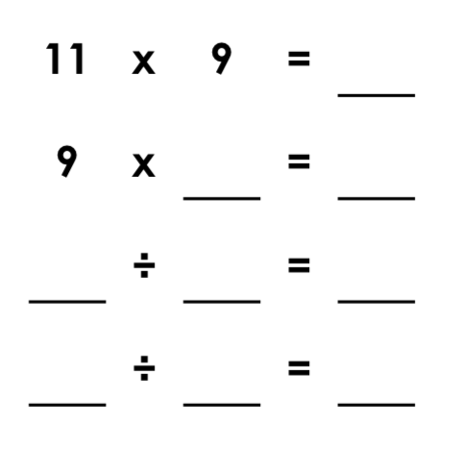
Answers

1. 54 ÷ 6 = 9; 6 x 9 = 54
2. 108 ÷ 9 = 12; 9 x 12 = 108
3. 63 ÷ 7 = 9; 7 x 9 = 63; 63 ÷ 9 = 7; 9 x 7 = 63
4. 99 ÷ 11 = 9; 11 x 9 = 99; 99 ÷ 9 = 11; 9 x 11 = 99
5. Fay is correct because all 2-digit multiples of 9 have a digit total of 9, for example: 18 = 2 x 9 and 1 + 8 = 9.
6. 36 = 4 x 9; 9 x 4 = 36; 4 = 36 ÷ 9
7. 5 x 9 = 45; 11 x 9 = 99
8. 11 x 9 = 99; 9 x 11 = 99; 99 ÷ 9 = 11; 99 ÷ 11 = 9

