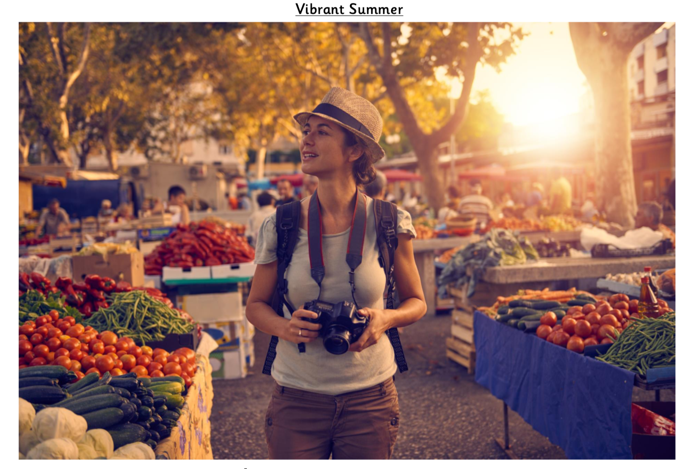
- Identify ONE question you would like to ask about this scene.
- How does this photo make you feel and why?
- How is the woman feeling and why do you think that?
- State TWO facts and TWO opinions about this photo.
- What is happening in this picture?
- List 5 different things you can see in this photo – be descriptive!
- Which word do you think best describes this scene and why? Vibrant, calm or busy.
- Would you show this image to someone else? Why/why not?
- Where might this picture have been taken?
- Why might this woman be taking photos? Think of as many different plausible reasons as possible.
Answers
- Identify ONE question you would like to ask about this scene. Various responses.

- How does this photo make you feel and why? Various responses. Possible answers might be that it makes them feel happy as it is full of colour, or jealous because it looks like a fun place to visit.
- How is the woman feeling and why do you think that? Various responses. Possible answers might be that she is feeling relaxed (the way she is stood), excited (a slight smile on her face), intrigued (something has caught her attention).
- State TWO facts and TWO opinions about this photo. Various responses. Possible answers might be FACT – There are lots of vegetables. OPINION – The woman is on holiday.
- What is happening in this picture? Various responses. Possible answers might reference the idea that the woman is on holiday and she is taking photos of the market she is walking through.
- List 5 different things you can see in this photo – be descriptive! Various responses. Possible answers might be: bottles of oil, creased table cloths, dazzling sunlight, rainbow array of vegetables, a huddle of people.
- Which word do you think best describes this scene and why? Vibrant, calm or busy. Various responses must be justified.
- Would you show this image to someone else? Why/why not? Answers must be justified.
- Where might this picture have been taken? Various responses. Possible answers might reference an outdoor market, possibly suggest it is abroad.
- Why might this woman be taking photos? Think of as many different plausible reasons as possible. Various responses. Possible answers might include holiday photos, food magazine.

