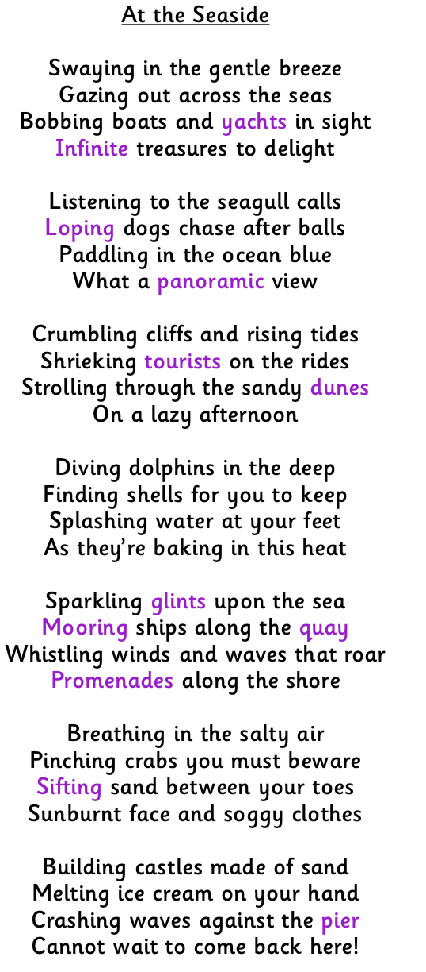
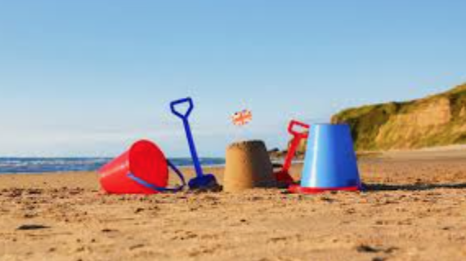

- What type of word does the first 3 lines of each stanza begin with?
- What is the rhyming pattern of this poem?
- Name 2 sounds that are described in the poem.
- Give an example of alliteration in this poem.
- What word means the same as walking slowly?
- What does the poet warn you to be aware of?
- Find 3 adjectives in this poem.
- Identify 3 sets of rhyming words.
- Why do you think the poet used the word ‘baking’ to describe the heat?
- Do you think the person who wrote this poem likes the seaside and why? Give evidence from the text.
- What time of year do you think is being described in this poem? Give evidence from the text.
- Name a place that you think this poem could be describing.
- How does this poem compare to other poems you have read?

What type of word does the first 3 lines of each stanza begin with? Verbs/words ending with the suffix ‘ing’.
Answers
What is the rhyming pattern of this poem? Rhyming couplets; A, A, B, B; or the first 2 lines and the last 2 lines of each stanza rhyme.
Name 2 sounds that are described in the poem. Seagull calls, shrieking tourists, whistling winds.
Give an example of alliteration in this poem. Diving dolphins, crumbling cliffs, bobbing boats, sifting sand.
What word means the same as walking slowly? Strolling
What does the poet warn you to be aware of? Pinching crabs
Find 3 adjectives in this poem. Sandy, gentle, salty, sunburnt, soggy.
Identify 3 sets of rhyming words. Tides and rides, sea and quay, sand and hand etc.
Why do you think the poet used the word ‘baking’ to describe the heat? To emphasise how hot it was/to liken it to an oven.
Do you think the person who wrote this poem likes the seaside and why? Give evidence from the text. Yes. The author says that there are “infinite treasures to delight” and that they “cannot wait to go back!”
What time of year do you think is being described in this poem? Give evidence from the text.
Summer. It talks about heat, melting ice cream, sunburn, paddling in the sea and the sun sparkling.
Name a place that you think this poem could be describing. Any coastal location eg. Scarborough.
How does this poem compare to other poems you have read? Personal response.

