Religious Education

Year: 4 Teacher: Mrs Smith Week Beginning: 13th July 2020
Ordinary people who do extraordinary things.
Read the information about Eric, a boy from Rwanda. His country was badly affected by war.
“Always look for ways you can live peacefully and be united.”
Rwanda has come a long way since the war. It is now a peaceful country and children are leading the way by taking care of each other. Thanks to your help, CAFOD can continue to help families like Eric’s by helping them find ways to help themselves through work, such as growing and selling vegetables.
Questions to discuss:
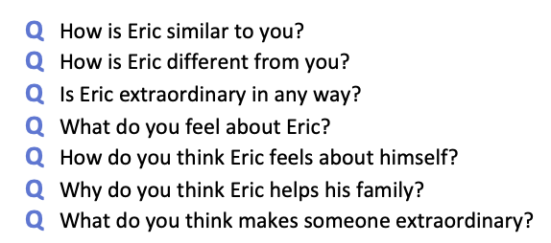
Complete the worksheet Eric me compare.doc. Once you are finished, send a photo to me at-
k.smith201@durhamlearning.net

