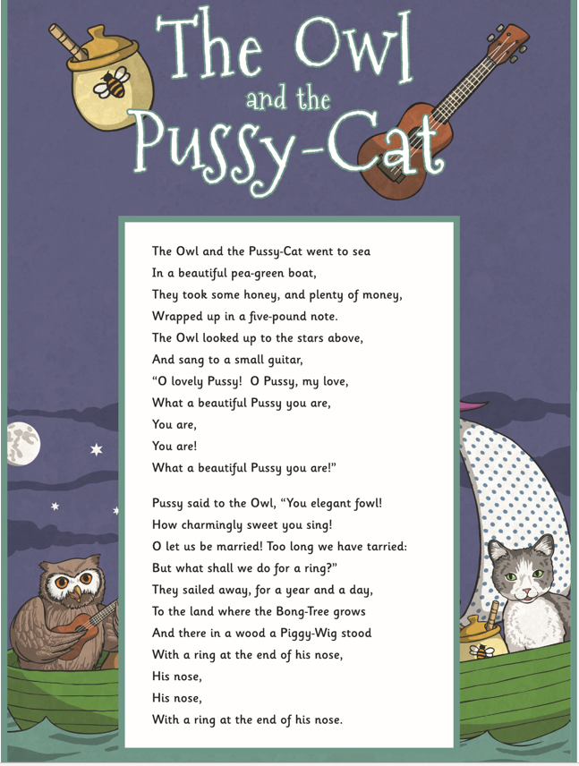
Questions

- Find and copy a word that means the boat looked great.
- Where was the honey kept?
- Find a phrase in the first verse that shows how the Owl feels about the Pussy-Cat.
- What does the word ‘fowl’ mean in the second verse?
- Why does the Pussy-Cat need a ring?
- What ideas are we given about the place that the Owl and the Pussy-Cat sailed to?
- Look at the verse beginning: ‘Dear Pig…’ Which phrase shows why the Owl and the Pussy-Cat were sailing away?
- Some people say the poem is about nonsense. Give two reasons why this might be true?
- There are many rhyming words in this poem. Can you find 4 examples?
- This is poem is a happy poem. Explain why using the text to help you

