Religious Education
Year: 5 Teacher: Mr McPhail Week Beginning: 6th July 2020

Over the past few weeks, you have looked at Freedoms and responsibilities, including the freedoms and responsibilities you have. We have also looked at the responsibilities given to us by the 10 commandments and the Beatitudes.
I would like you to plan a simple liturgy to reflect on what we have covered in our Freedom and Responsibility lessons. I have also included a liturgy in the Resources area of our Home Learning Area to give you ideas!
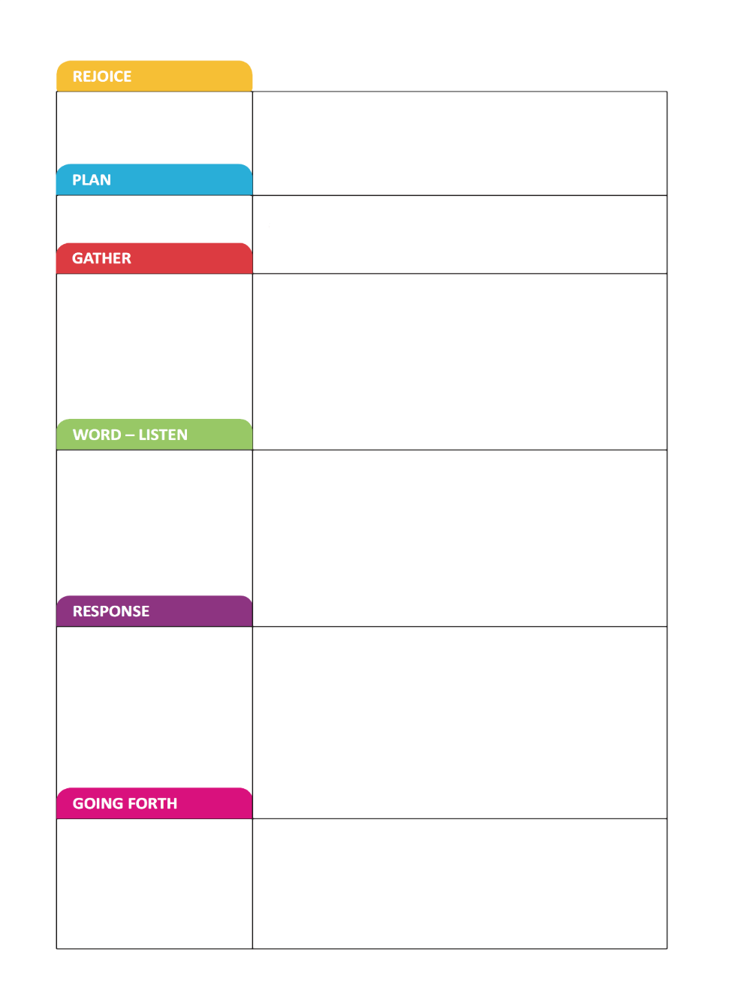
Use what you have remembered and your
reflections to help to plan our class celebration of this topic .

Freedom and Responsibility
I want to include
How will we gather?
Why?
Which scripture from the topic would you like to use?
Why?
What action, prayer response would you like to include?
Why?
How will we end and carry the message to others in some way?
Why?

