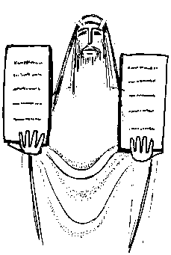
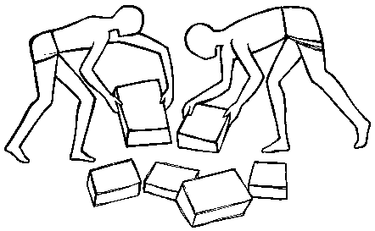

Act of Worship
Year 5
FREEDOM AND RESPONSIBILITY
“God’s rules for living freely and responsibly – the Commandments”

You may like to set up a focal table:
Table with a cloth and a candle
Gathering
Together
Bible if possible
Any work done on the topic

We begin our liturgy on ‘Freedom and Responsibility’ by making the Sign of the Cross In the name of the Father…
And by lighting our candle and remembering that God is present in our gathering……

People who want to live or work together make rules for themselves. The rules give them freedom to live as they wish, but at the same time, be responsible for the happiness of the whole group.

We have surely all wished, at one time or another that we could go through life without having to obey rules. “It would be great if I could just do as I want”, we might say.
But when we stop to think about it, if we had no rules to obey, then what some people want to do, might harm, or put at risk, others around them – and probably themselves as well.

Rules are there to protect us all, and to make our lives more pleasant. Some of these rules that govern our lives can be seen at home and in school, and they ensure that we think of others, as well as of ourselves. They help us to behave more responsibly. Some of the rules we are following at the moment (staying at home. social distancing, washing hands) are there to keep us and others safe and to protect the NHS.

The Word
of God
We are now going to hear about some of the earliest rules which were written down; rules which were given to us by God himself, through his contact with the great Jewish leader, Moses. God chose Moses to lead the people of Israel out of slavery in Egypt, but he soon discovered that, although they were all supposed to follow the Jewish religion, the Jews were a very quarrelsome group. They refused to do what Moses asked them to – so he sought God’s help to give them rules, which would make them all to be free, but responsible for their actions, and would encourage them to be more considerate of others.

Reader: A reading from the Book of Exodus
Moses climbed to the top of Mount Sinai. He remained on the mountain for a very long time, praying and talking with God. Then he returned to God’s people and told them God’s Laws – the Ten Commandments.
I am the Lord, your God. Love, serve and promise me to keep my name holy.
Keep my day holy.
Love and obey your parents and those who have charge of you.
Do not kill, and do not be angry or bad-tempered.
Respect and care for other people.
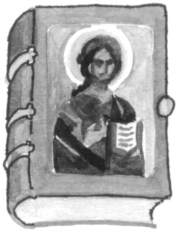
Do not steal, cheat or want things that don’t belong to you.
Tell the truth and speak kindly of others.
Do all you can to care for others and make them happy.
Do all you can to care for other people’s belongings.

The Word of the Lord.
Thanks be to God.

Those rules were so appropriate for living a more responsible life, that today they are still the basis for many of our own laws – and those of other countries too.
Response to
the Word

We all know that we are supposed to obey rules which are there to ensure that each of us lives our lives to the best of our ability. But we also know that at times we do not succeed. Examine your conscience for a moment and think of a time when you deliberately chose to break rules and weren’t responsible in your actions………

In the Sacrament of Reconciliation we celebrate God’s love and mercy. We learn about the joys and challenges of living as a follower of Jesus in love and peace. During the celebration of the Sacrament of Reconciliation the Church celebrates the love and mercy of God and calls people to confess their sins, ask for forgiveness and be reconciled to God and to one another. During the Sacrament of Reconciliation, the Act of Contrition, also called the Prayer of Sorrow, is said. Let’s say that prayer together now for all the times we didn’t use our freedom responsibly and broke important rules for living…

O my God, because you are so good,
I am very sorry that I have sinned against you
and with the help of your grace I will not sin again. Amen
Going
Forth
For the next week let’s try to pray the Act of Contrition every evening before bed to say sorry for the times during the day we haven’t lived responsibly.

To end our liturgy let’s say together:

God our Father, you have given us freedom in our lives.
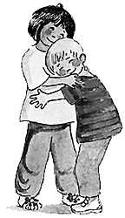
With this freedom we can bring sorrow or joy to ourselves and to others.
Help us always to use our freedom in a responsible way.
We make this prayer through Christ our Lord. Amen.

