Year 4 English Planning—WB 22nd June
Weekly Focus: Punctuation
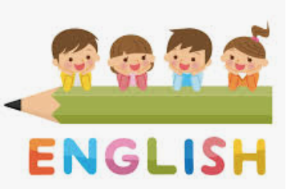
 | Activity
Monday | Spelling activity  Practise Spelling rule 17 - Words ending with the /g/ sound spelt – gue and the /k/ sound spelt –que (French in origin) (e.g. rogue, unique, etc)  https://spellingframe.co.uk/spelling-rule/20/17-Words-ending-with-the-g-sound-spelt–gue-and-the-k-sound-spelt-–que-(French-in-origin)
Tuesday | Grammar Activity –Fronted adverbials using a comma  Watch the video  https://www.youtube.com/watch?v=8lOQGyMhp_Q  Rewrite the sentences (see resources) with the adverbial at the beginning of the sentence (remember your comma).
Wednesday | Reading Comprehension Activity  Read the text The Same but Different and answer the questions in your book
Thursday | Writing Activity  Complete a piece of writing from the Foundation planning
Friday | Spelling Quiz  Recap your spelling and test yourself  https://spellingframe.co.uk/spelling-rule/20/17-Words-ending-with-the-g-sound-spelt–gue-and-the-k-sound-spelt-–que-(French-in-origin)
Reading – Read Time Zone from the Oxford Owl elibrary https://www.oxfordowl.co.uk/api/interactives/30563.html

