Reasoning and Problem Solving – Subtract two four-digit numbers

.
1. Duaa says,
Is the calculation correct?
Do you agree with Duaa? Explain your answer.
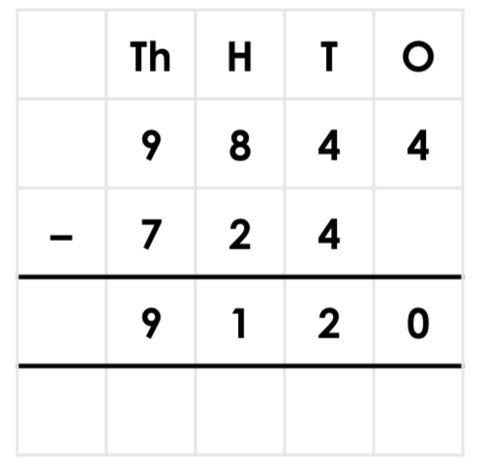
2. Complete the calculation below.  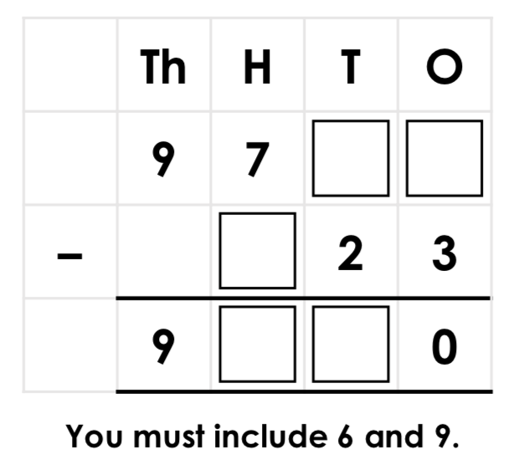 | 3. Complete the calculation below.  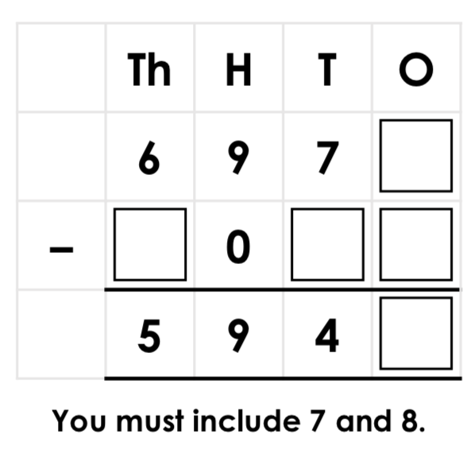
4. Explain the mistake in the calculation below.  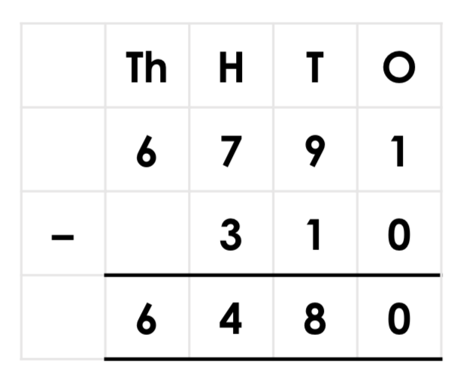 | 5. Explain the mistake in the calculation below.  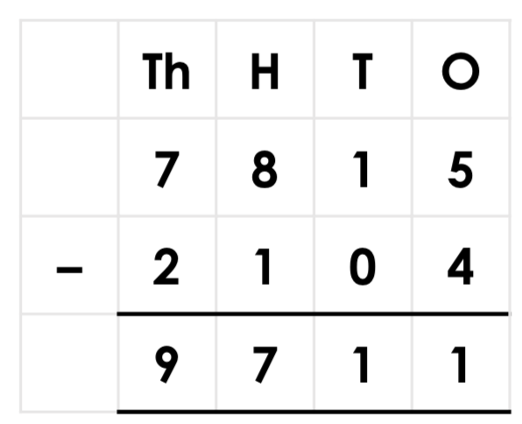

6. Peter has subtracted 1,053 from 3,675. He has put the numbers into the place value chart to show his answer.  Is he correct? Explain why. | 7. Rochelle has subtracted 4,501 from 7,593. She has put counters into the place value chart to show her answer.  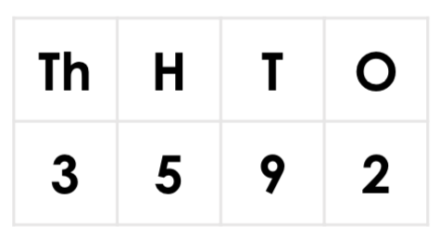  Is she correct? Explain why.
8. Explain the mistakes in the calculation below.
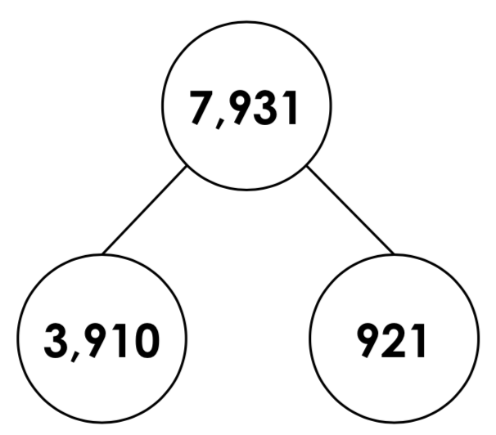

Answers

1. The calculation is wrong because the numbers have not been written in the correct columns. The calculation would need to be 9844 – 724 to give the answer provided.

2. Possible answers: 9,793 – 623 = 9,170; 9,793 – 123 = 9,670

3. Possible answers: 6,978 – 1,037 = 5,941; 6,978 – 1,031 = 5,947

4. The ones column is incorrect. 1– 0 = 1, not 0. The answer should be 6,481.
5. he thousands column is incorrect. It has been added instead of being subtracted. The answer should be 5,711.
6. Peter is incorrect. He has subtracted the thousands column incorrectly. The answer should be 2,622.
7. Rochelle is incorrect. She has forgotten to subtract the hundreds column. The answer should be 3,092.
8. Various answers, for example: 921 is incorrect. It should be 4,021. This can be seen if the numbers are rounded to the nearest thousand. 8,000 – 4,000 = 4,000 so the remaining number should be close to 4,000.

