Reasoning and Problem Solving – Multiply by 6

.
1. Ruby rolls a dice 3 times and it lands on 6 every time.  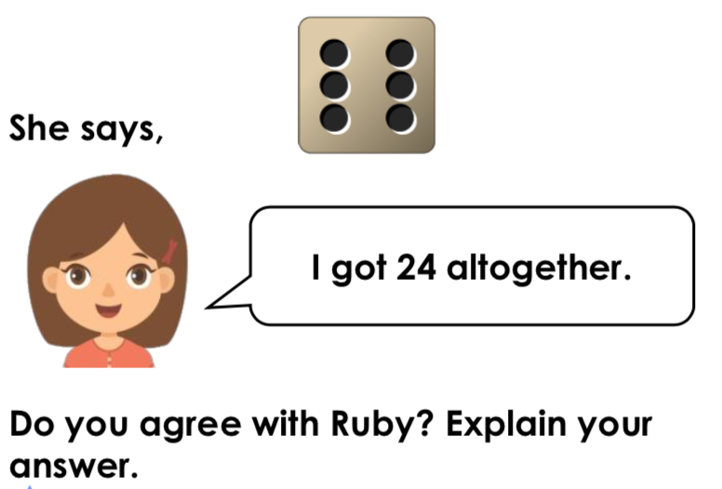 | 2. Ben rolls a dice 7 times and it lands on 6 every time.  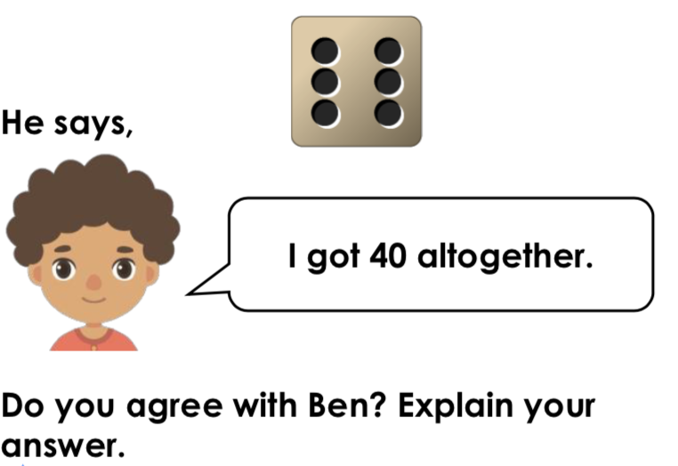
3. Use the cards below to create as many calculations as you can.  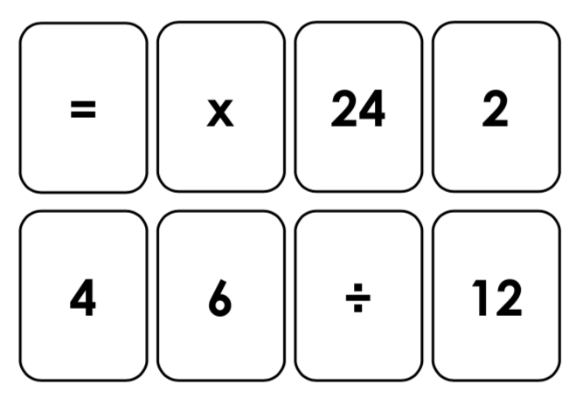 | 4. Use the cards below to create as many calculations as you can.  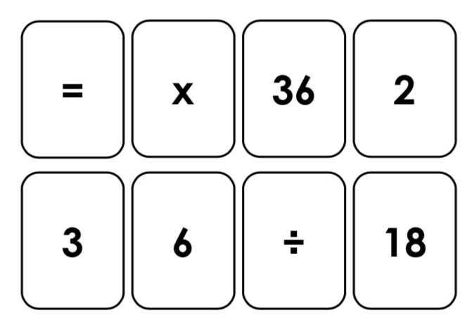
5. Max is trying to solve the calculation below.  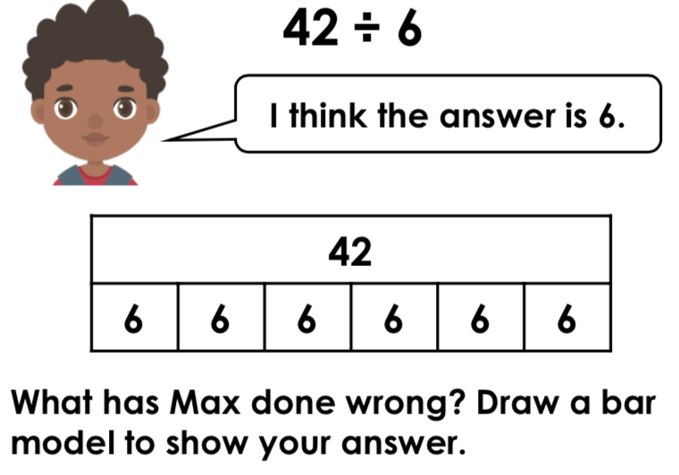 | 6. Katie is trying to solve the calculation below.  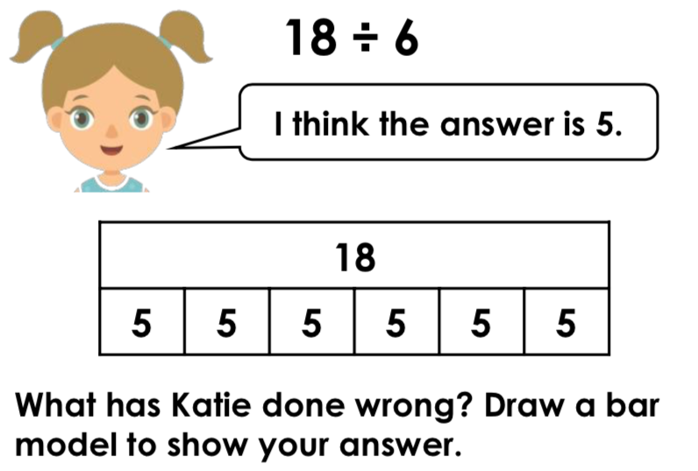

7. David says, “I am not confident with my 6 times tables but I know my 3s so I can use this to help.” Is David correct?

8. If I know my 6 times tables, I could use this to work out 60 x 70. Is this correct? What is the answer?

Answers

- Ruby is not correct because 3 x 6 = 18, not 24
- Ben is not correct because 7 x 6 = 42. He has miscounted.
- Various answers, for example: 24 ÷ 6 = 4, 2 x 6 = 12
- Various answers, for example: 36 ÷ 6 = 6, 3 x 6 = 18
- Max has got the wrong answer because 42 ÷ 6 = 7. He has drawn his bar model incorrectly.
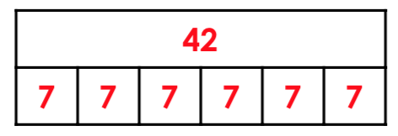

- Katie has got the wrong answer because 18 ÷ 6 = 3. She has drawn his bar model incorrectly.
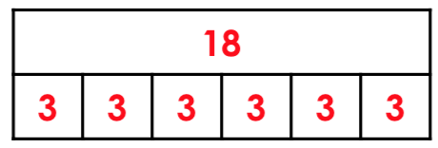
- David is correct because he can double the answer to the 3 times table to find the answer to the 6 times table.
3 x 4 = 12
6 x 4 = 24
8. Yes, because I have just changed the place value of the digit. I can take of the zeros, do the calculation and add the zeros back onto the answer.

