Reasoning and Problem Solving – Inverse operation

.
1. Tom has written some calculations based on this bar model.  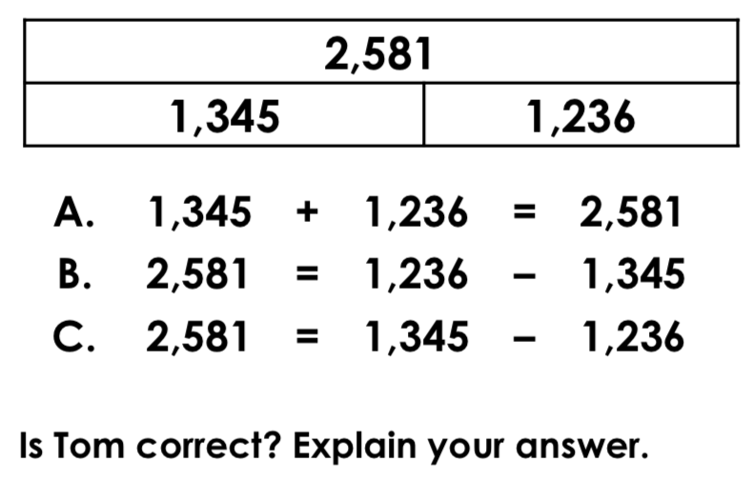 | 2. Find the related numbers through addition and subtraction.  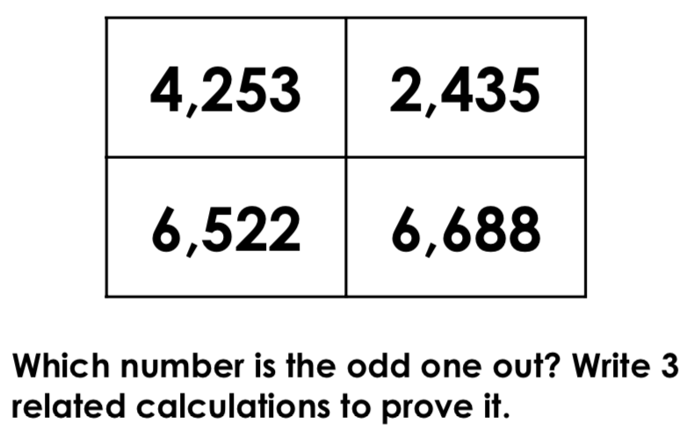
3. Using the digit cards, create a calculation that equals 3,846. The digit cards can be used more than once in the same number.  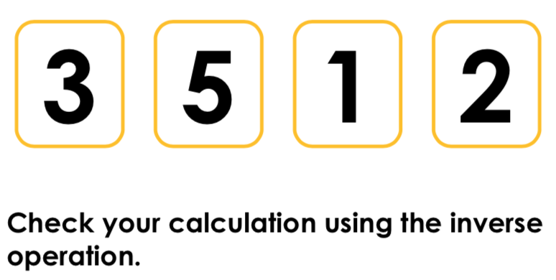 | 4.  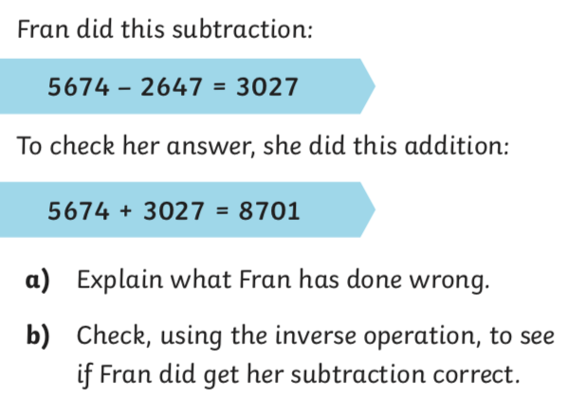
5.True or false? Mildred can use calculation B to check the answer to 3,756 + 5,906 = 9,671.
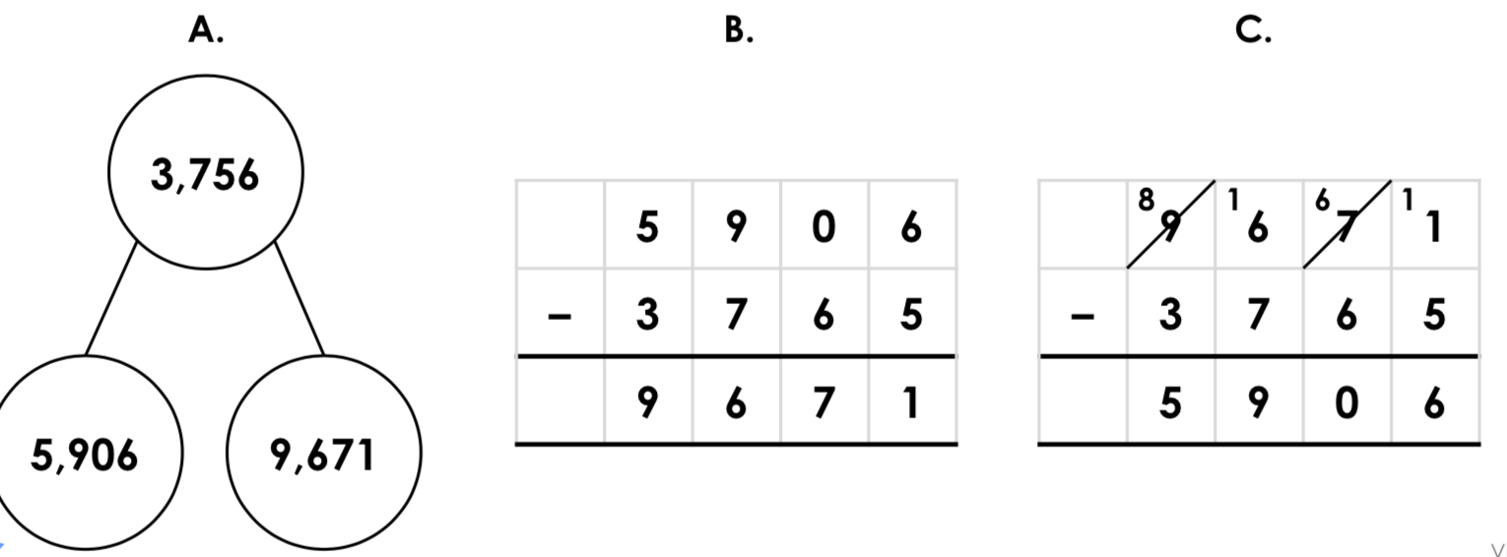

6. Match the calculation to its inverse.
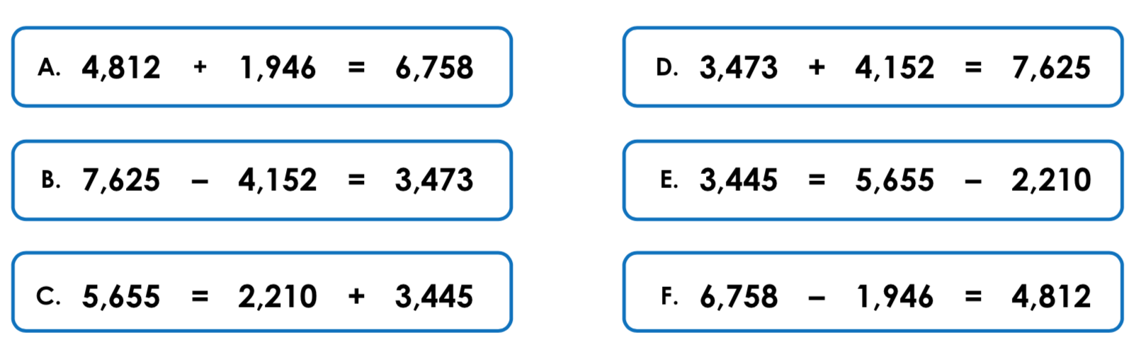

7. George and Samira are discussing how they would check the following calculation using the inverse.
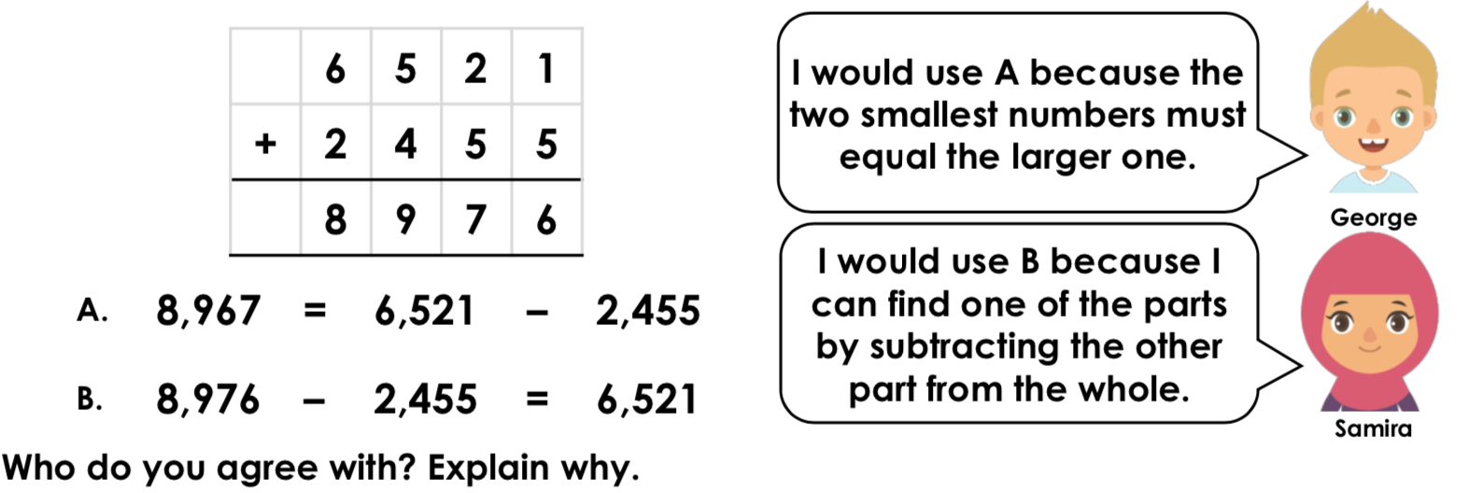
8.
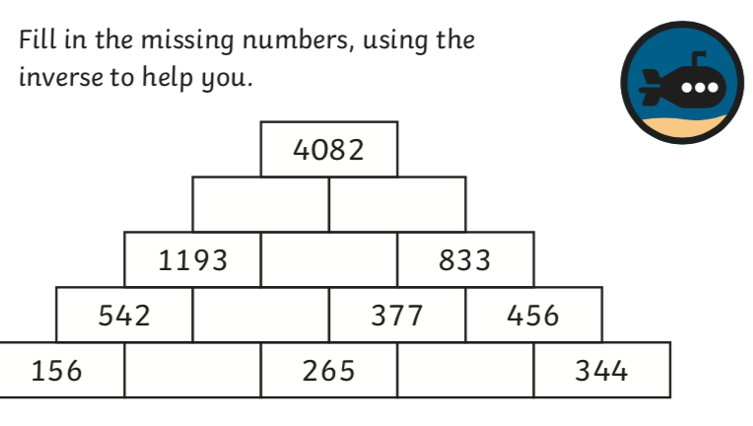

Answers
- B and C are incorrect. For the answers to work, the = and – signs could be swapped, or the – could be changed to +.
- 6,522 is the odd one out. 4,253 + 2,435 = 6,688; 6,688 – 2,435 = 4,253; 6,688 – 4,253 = 2,43
- Various answers, for example: 1,325 + 2,521 = 3,846; 3,846 – 2,521 = 1,325 3,335 + 511 = 3,846; 3,846 – 511 = 3,335
- a) Fran has chosen the wrong numbers to add when trying to calculate the inverse. She should have done 3027 + 2647 or 2647 + 3027.
b) Fran did get her calculation correct.
- False
- A and F, B and D, C and E
- Samira is correct because George’s subtraction would not equal 8,976 as he has used subtraction rather than addition, whereas her calculation would equal 6,521.

