Reasoning and Problem Solving – Subtract two four-digit numbers (one exchange)
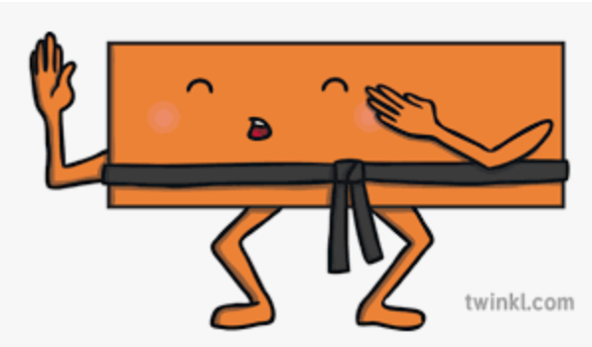

.
1. Complete the calculation below.  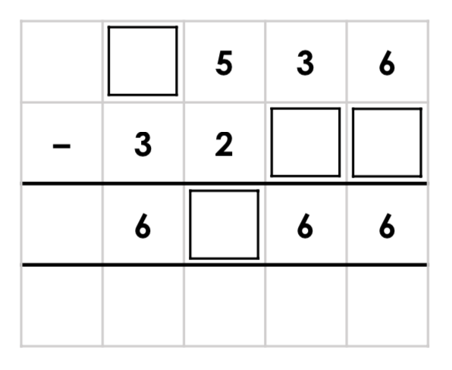 | 2. Complete the calculation below.  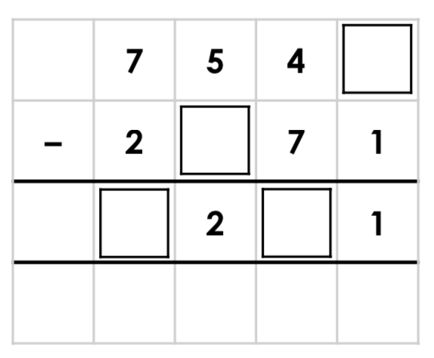
3. Class 4 are given the following calculation. Zainab says,  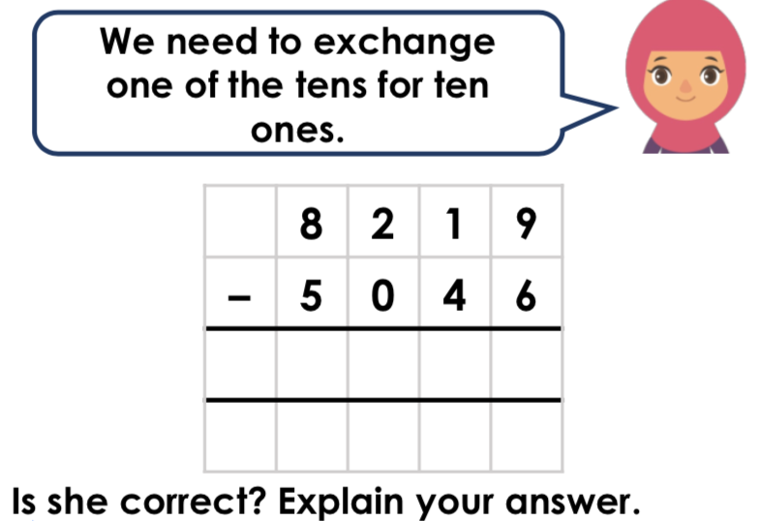 | 4. Class 4 are given the following calculation. Adam says,  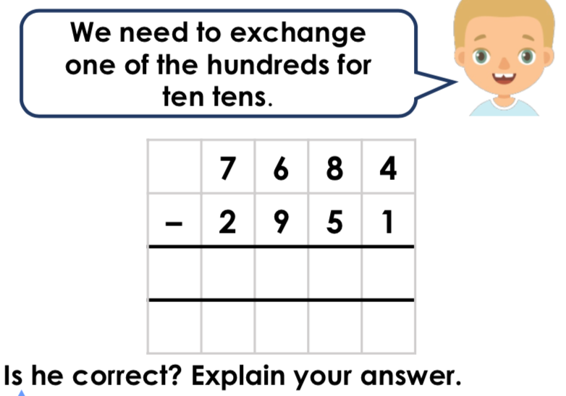
5. True or false? B creates the smallest answer. Complete each calculation to check.
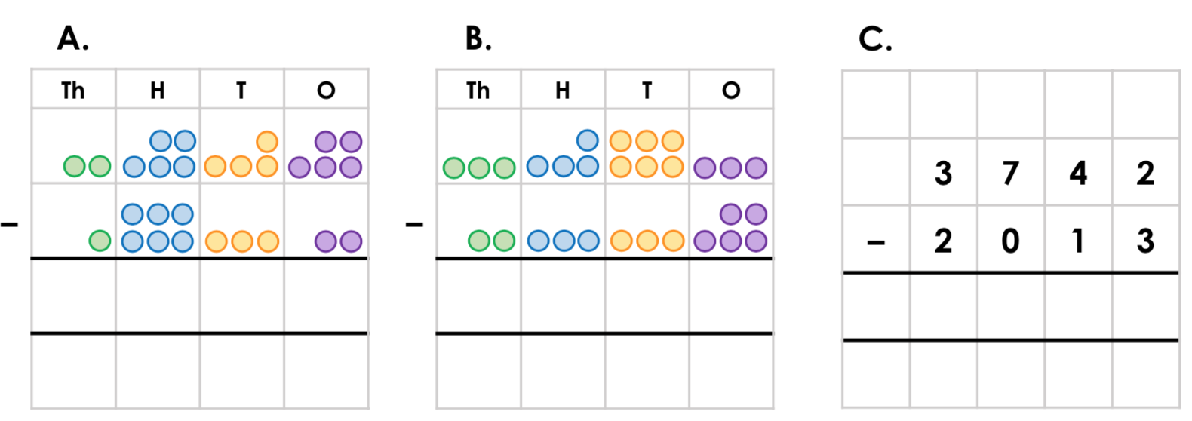

6. Identify the incorrect answer below and correct it.
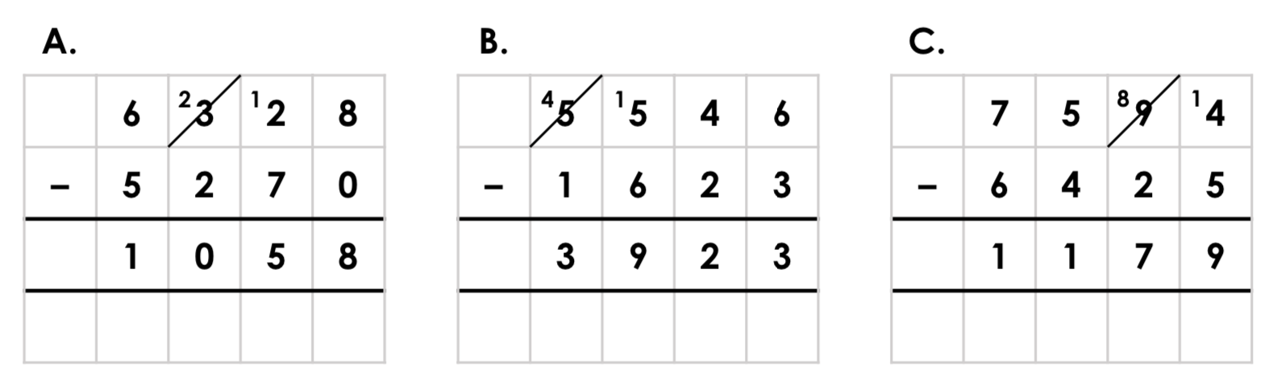
7. Class 4F have been given the subtraction below to complete. Avneet says:
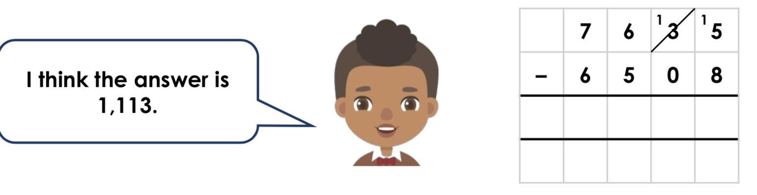
8. Use digits from 0 - 9 to create a subtraction calculation with two 4-digit numbers and one exchange.
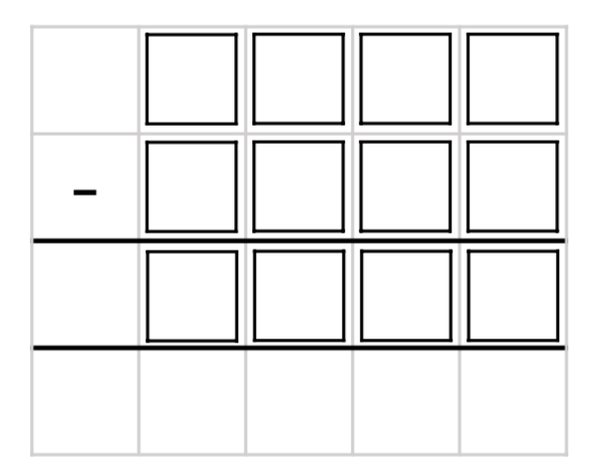

Answers
1. 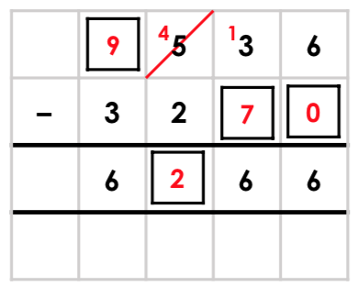
2.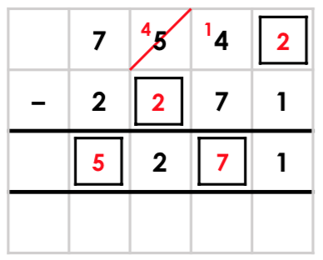
3. Zainab is incorrect. They need to exchange one of the hundreds for ten tens.
4. Adam is incorrect. They need to exchange one of the thousands for ten hundreds.
5. False. A creates the smallest number because A = 913, B = 1,128 and C = 1,729.
6. C is incorrect. The correct answer is 1,169.
7. Avneet has exchanged the 3 tens incorrectly. He has borrowed 10 and should have 2 tens remaining, not 1 ten. The correct answer is 1,127.
8. Various answers, for example: 7,654 – 2,345 = 5,309; 6,523 – 3,602 = 2,921; 8,349 5,721 = 2,628 etc.

