From: Matthew Storey

Good morning,

Do you want to live in a damaged world?

We need to stop polluting our planet!

No one wants to be in a world without animals and wildlife

We should all stop using plastic straws. We should all have our own bottle to reuse over and over, instead of buying single use bottles.

Always recycle and never just put plastic in the bin.

Thank you from Matthew Storey

Attach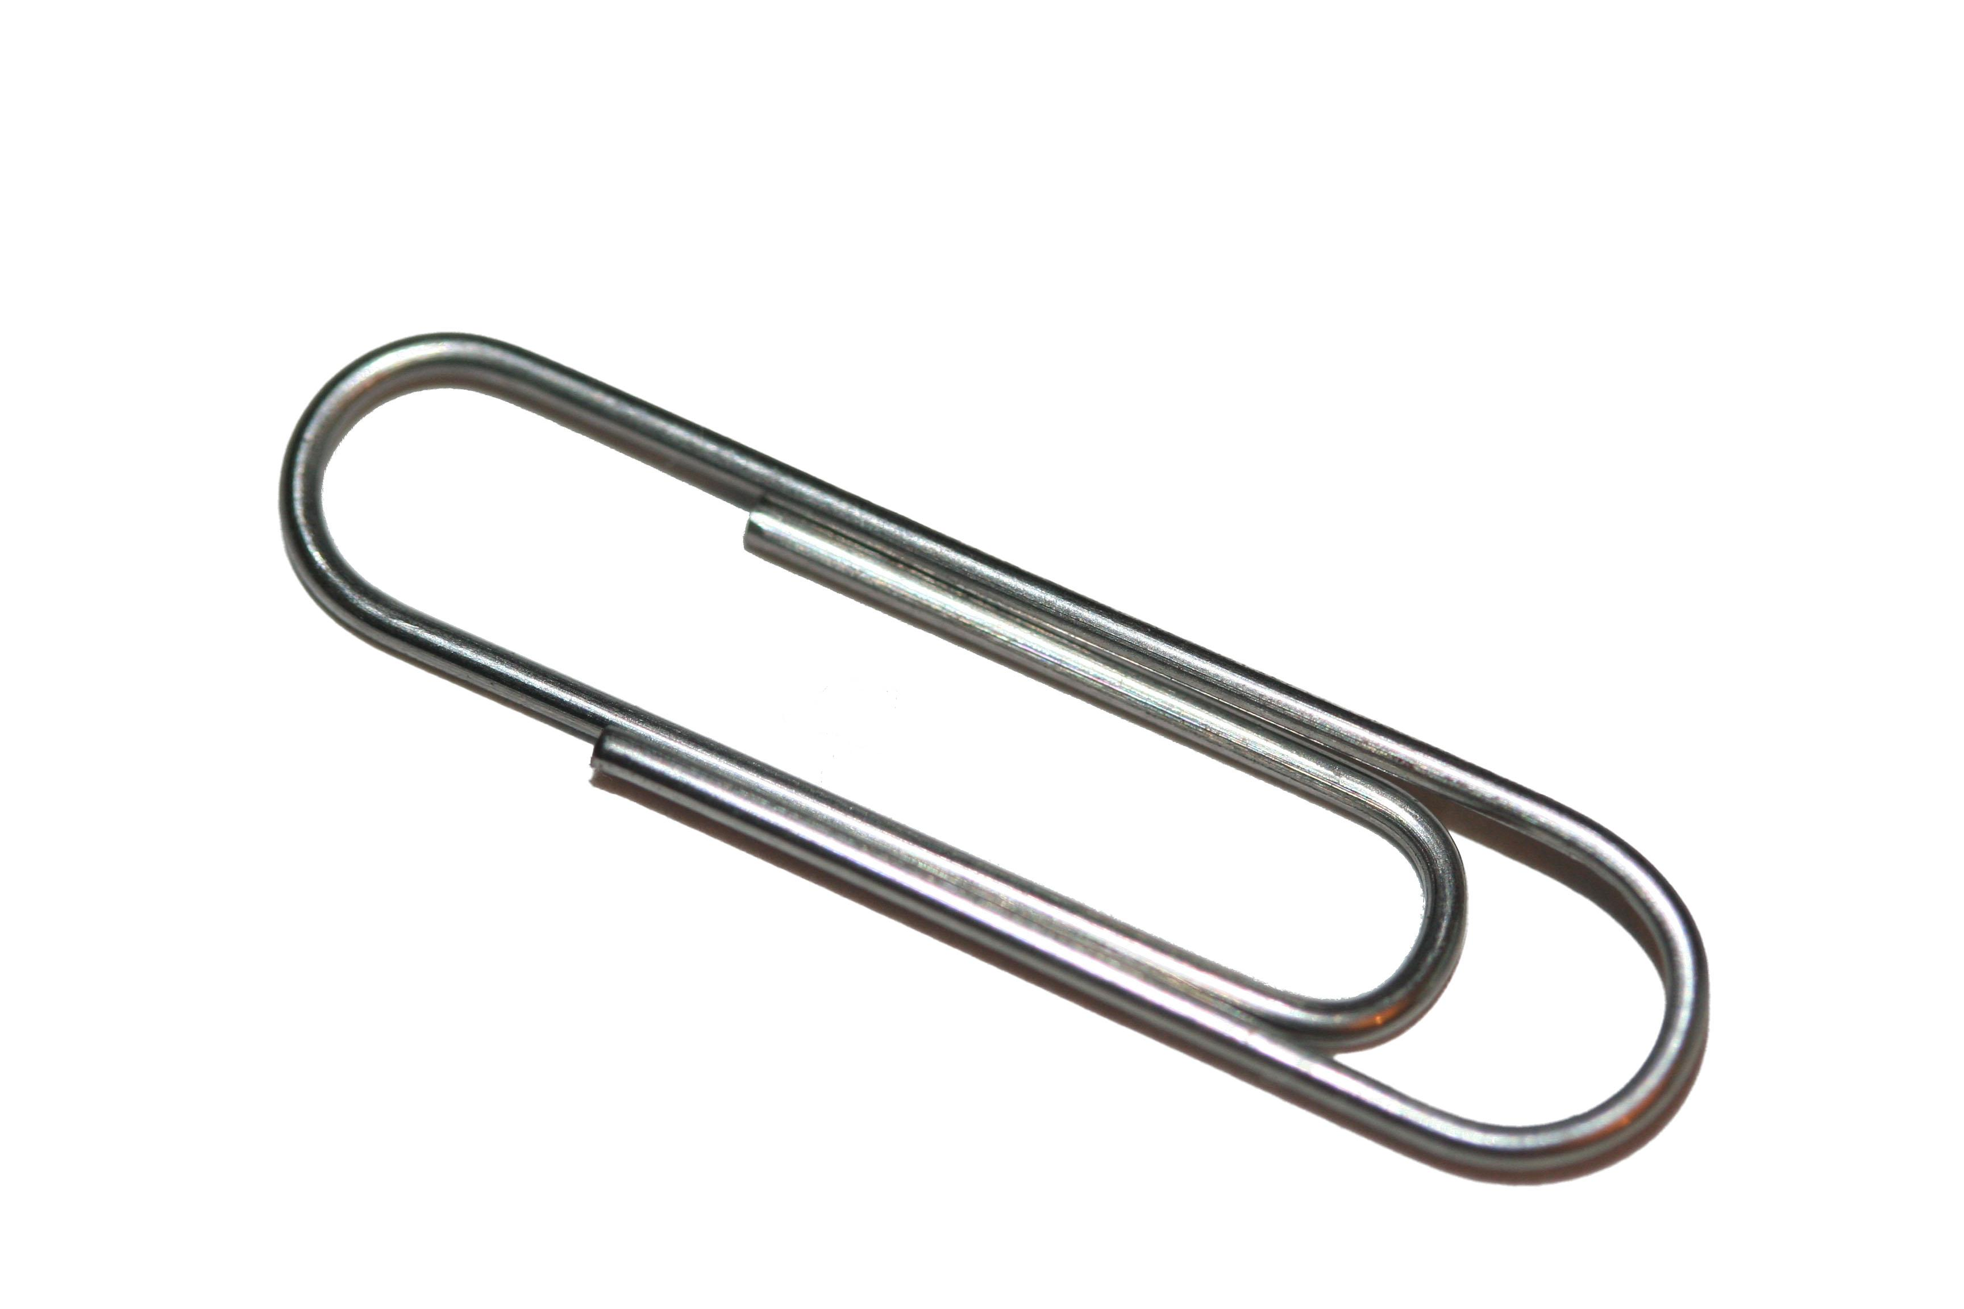

Send

Subject: plastic waste

To: j.brack@durhamlearning.net